Guide on making your own reusable Non-medical face mask
The following link demonstrates how to manufacture a selection of Non-Medical face coverings:
https://www.cdc.gov/coronavirus/2019-ncov/prevent-getting-sick/diy-cloth-face-coverings.html
Mrs Bell produced a few different samples following the instructions and sometimes using different materials and steps to accommodate what people might or might not have.
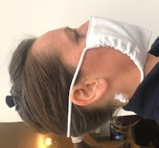
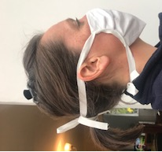
100% cotton is ideal so the wearer can wash it at high temperatures after use.

Mask 1
- Folded fabric
- Pleated
- Ribbon or tape sewn down both sides

Mask 2 & 3 (lining to accommodate filter and wire)
- Folded fabric
- Both sides folded in and sewn down to create a channel
- Ribbon or bias binding sewn at the top to create a holder for a wire/pipe cleaner
- Thread cord, elastic or ribbon through side channels.

Mask 4 -NO SEWING necessary!!!
- Cut a t-shirt as guided from instructions on website

Mask 5- Most complex design
(lining to contain filter and wire)
Pattern pieces, instructions and YouTube guide on the following website:
https://www.craftpassion.com/face-mask-sewing-pattern/

