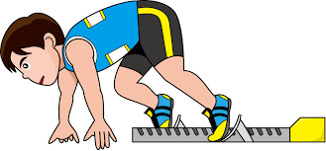
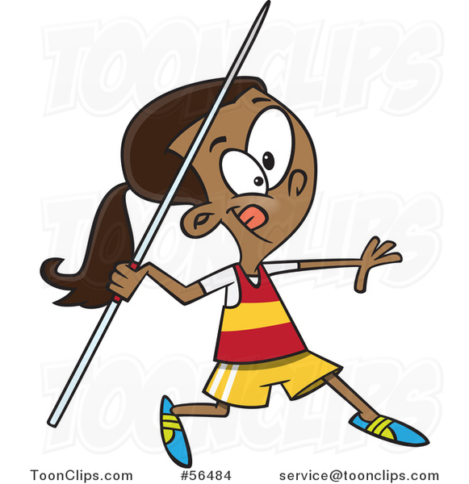
ATHLETICS

Part 1 – Skills (10 Marks)
Mark | Sprinting | Hurdling | Middle Distance | Jumping | Throwing
9-10 | I can consistently use a sprint start and dip finish with precision. I can generate power and speed with an effective and consistent arm and leg action. | I can effectively use an efficient hurdling action, showing correct lead, trail leg and body position over the hurdle. I sprint efficiently and maintain pace both on the flat and over the hurdle. | I can demonstrate an efficient running technique consistently. I am able to change pace when it is required in a race depending on the position of opponents or for a sprint finish. | I can perform jumps showing that run up generates speed and that my take off is accurate. I am able to use the correct technique during flight and land correctly. | I can perform throws showing the correct grip, stance and movement into the throwing action. I can also release, follow through and recover correctly.
7-8 | I can use a sprint start use a dip finish consistently and regularly produce the intended outcome. I can consistently perform an effective arm and leg action to create an effective speed. | I can perform an effective hurdling action consistently and regularly produce an effective outcome. I use an effective sprint action between the hurdles to create power and speed. | I can perform an effective and efficient arm and leg action to maintain pace throughout the race. I can conserve energy to then change pace when this is required most of the time. | I can perform all three jumps, showing good technique through the three phases. I can generate speed on the run up, power on the take off and land correctly most of the time. | I can perform all three throws, showing good technique through the three phases. I generate momentum before the release to increase the thrown most of the time.
5-6 | I understand the start and finish rules and techniques. I can use a sprint start and the dip finish with good technique most of the time. I can use an effective arm and leg action to create consistent speed. | I can use a basic hurdling action with good technique most of the time. I can perform the front and trail leg action and lower my upper body to attempt to be more aerodynamic over the hurdle. | I understand the technique required to create and maintain an appropriate pace. I can effectively demonstrate this throughout the race and attempt to change pace when necessary. This is not always consistent. | I can perform at least two of the jumps with good technique; showing speed on the run up and power on take off. I can land safely and effectively to gain the best possible outcome most of the time. | I can perform at least two of the throws with good technique; showing accurate grip and stance, movement into the throw and follow through most of the time.
3-4 | I understand the start and finish rules and techniques. I can perform a standing start with some success. I can use a basic arm and leg action to create an appropriate pace. | I can attempt the front and trail leg action of the hurdling technique with some success. I can use a basic sprinting action between hurdles to create an appropriate pace. | I understand the correct arm and leg action required and breathing technique to be efficient. I try to maintain an appropriate pace, but this is not always consistent. | I can perform the basic technique for the take off and flight phase of the jumps. I sometimes struggle to combine this with a run up. | I can perform a basic technique for the shot and javelin throw. I can use a basic grip and stance, but I struggle to combine movement into the throw.
1-2 | I understand the start and finish rules and techniques. I can use a basic arm and leg action; this is not always at an appropriate and consistent pace. | I understand the hurdling technique. I can occasionally perform the front leg action. I try to use a sprint technique between hurdles but this is not always at an appropriate pace. | I understand how to approach a middle distance race and how to maintain a consistent pace throughout. I try to apply this to a race, but I struggle to maintain this for the whole distance. | I understand the three phases of the jump events. I can attempt to perform these, but I often lack speed and power to generate height or distance on the jump. | I understand the rules and techniques of the throwing events. I attempt to perform these, but action is not always correct and I lack distance in my throw.
Part 2 – Competitive Situation (15 Marks)
13-15 | I show that I can effectively make tactical and strategic decisions to maximise performance in both events over other competitors  I am able to sustain high level technique, accuracy and consistency in my performance  I am able to apply technique and tactics, and I am usually success in maximising my potential to excel against other very high ability competitors.
10-12 | I show that I can usually make effective tactical and strategic decisions to gain an advantage over other competitors  I am usually able to demonstrate high level technique, accuracy and consistency in my performance  I am able to apply the most appropriate technique and tactics. I often maximise my potential to excel against other high ability competitors.
7-9 | At times, I show that I can make successful tactical decisions to gain an advantage over other competitors more so in one event.  I am sometimes able to demonstrate correct technique and accuracy although I sometimes lack consistency in my performance  I have some ability to apply the appropriate technique and tactics to succeed against good but not high ability competitors. I sometimes maximise my potential.
4-6 | At times, I show some ability to make tactical decisions to gain an advantage over other competitors, but this is not very consistent.  I show some technique and accuracy in my performance and there are obvious weaknesses.  I occasionally have some ability to apply the appropriate technique and tactics. I occasionally maximise potential. I still find it hard to succeed against proficient competitors.
1-3 | I show limited ability to perform in two athletic categories to gain an advantage over other competitors  I show limited technique in my performance, it lacks accuracy and there are obvious weaknesses.  I show limited ability to apply the appropriate technique and tactics, rarely maximising potential against low level competitors.

