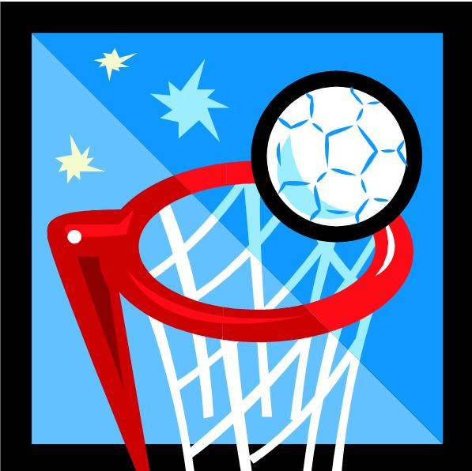
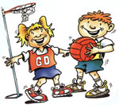
NETBALL
Part 1 – Skills (10 Marks) (Italics and brackets means it is not assessed within the GCSE skills)
Mark | Passing and Receiving | Dodging | Marking | Shooting/rebounding/marking a pass/intercepting | Footwork and Movement
9-10 | I can consistently perform effective passes including chest and shoulder passes that reach the target. I can effectively receive the ball without losing control. (one handed catches are consistent) | I can consistently lose my opponent using a single, double or sprint dodge. I use this to effectively find space to receive a pass from a teammate. | I can stay with an opponent by adjusting my body position all the time to stop them from getting free. | I can effectively shoot from both close range and distance. I rarely miss.  I consistently win rebounds after a shot to gain possession.  I can effectively mark a pass to make it difficult for an opponent to make the pass and usually can time an interception to win the ball back. | I effectively demonstrate good footwork and can land on one or two feet and pivot without giving away a foul. (pass on move)
7-8 | I can perform a variety of passes, including chest and shoulder with consistency. I regularly produce the intended outcome. I can receive the ball with good technique. (one handed catches most of the time) | I can often lose my opponent using a single, double or sprint dodge. I usually am able find space to receive a pass. | I can usually stay with an opponent. I use my body position well to stop them from getting free most of the time. | I can shoot with good technique from close range and distance and often produce the intended result.  I can often win rebounds after a shot to gain possession for my team.  I can mark a pass and intercept the ball with good technique. | I demonstrate good footwork and land on one or two feet and pivot well. (I can receive an accurate pass on the move.)
5-6 | I can perform passes such as the chest and shoulder with consistency. I can receive the ball with two hands. (I often lose control when receiving with one hand) | I can sometimes lose my opponent often using a single or double dodge. I can sometimes use a sprint dodge, but I am often not moving quickly enough to receive a pass. | I can often stay with an opponent and make it difficult for them to get free to receive a pass. | I can shoot and my technique is good but my accuracy is lacking from distance.  I will attempt rebounds, but only win them about half of the time.  I can mark the ball and intercept poorer quality passes from the opposition. | I demonstrate footwork and can land on one or two feet and pivot. (I can sometimes receive a simple pass on the move. )
3-4 | I can perform passes such as the chest and shoulder pass with some success. I can usually receive the ball with two hands. | I sometimes struggle to get free as I do not move quickly enough into a space using either a single, double or sprint dodge. The pass is sometimes intercepted. | I sometimes struggle to keep up with an opponent. This means that they can get away from me into a space and receive a pass. | I can perform a shot from close range but only occasionally produce the intended result. I can perform a rebound but only sometime produce the intended result.  I struggle to intercept the ball from opponents when it is played with pace although I will attempt it. | I can perform correct footwork and pivoting when on the spot but only occasionally produce the intended result when moving.
1-2 | I can perform some two handed passes with some success, although it will often lack either the accuracy or power. I can receive the ball with two hands with some success but I often lose possession. | I am often too static to get away from my opponent. As a result I struggle to find enough space to receive a pass without it being intercepted. | I am too static when marking and my opponent usually gets away from me quickly and into a space. | I understand how to shoot but rarely perform it with the correct technique.  I understand what a rebound is and can sometimes attempt it, with limited technique.  I understand what an interception is and can sometimes attempt it, with limited technique. | I understand what good footwork is but perform it rarely with any accuracy.

Part 2 –Game Situation (15 Marks)
13-15 | - TACTICS: I can show a high level of successful and effective tactical and strategic decisions, almost always relevant to the position I am playing. CONTRIBUTION: My contribution is highly effective and I sustain this for almost all of the game. TECHNIQUE & ACCURACY: I show high level of technique and accuracy for all skills consistently when in set play and in open. APPLICATION OF SKILL: I select the appropriate stills. OPPONENTS: I am usually successful in outwitting my opponent and I am hardly ever outwitted.
10-12 | - TACTICS: I can make successful and effective tactical and strategic decisions usually relevant to the position I am playing. I have minor tactical lapses. CONTRIBUTION: My contribution is usually effective and I sustain for the majority of the game. TECHNIQUE & ACCURACY: I show technique and accuracy for all skills when in set play and in open. APPLICATION OF SKILL: I usually select the appropriate stills, there may be some lapses. OPPONENTS: I can often outwit my opponent and I am only occasionally outwitted.
7-9 | - TACTICS: I can make successful and effective tactical and strategic decisions and but I still have some tactical weaknesses and occasionally my tactics aren’t relevant to the position I am playing. CONTRIBUTION: My contribution is sometimes effective and I don’t sustain it throughout, sometimes I am uninvolved. TECHNIQUE & ACCURACY: I show technique and accuracy for most skills when in set play and in open play but it is not always consistent. APPLICATION OF SKILL: I select the appropriate stills most of the time. OPPONENTS: I can sometimes outwit my opponent, even with obvious areas of weakness and I am sometimes outwitted.
4-6 | - TACTICS: I show limited ability to make tactical and strategic decisions and they are rarely relevant to the position of my opponents. CONTRIBUTION: I contribute infrequently and they are only occasionally effective or significant. TECHNIQUE & ACCURACY: I show some technique and accuracy for some skills when in set play and open play but I still have obvious weaknesses and inconsistencies. APPLICATION OF SKILL: I occasionally select the correct skill. OPPONENTS: I occasionally outwit my opponent and I am often outwitted.
1-3 | - TACTICS: I show some ability to make tactical and strategic decisions and there are weakness in their relevance to the position I am playing. CONTRIBUTION I contribute on rare occasions and it is ineffective or insignificant. TECHNIQUE & ACCURACY: my technique and accuracy is limited to a few skills when in set play and open play. APPLICATION OF SKILL: I rarely select the correct skill. OPPONENTS: I rarely outwit my opponent and I am usually outwitted.

