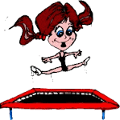
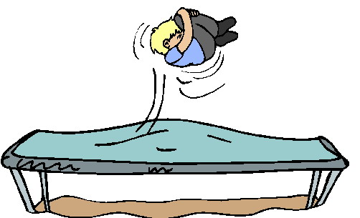
TRAMPOLINING
Part 1 – Skills (10 Marks)
Mark | Shapes | Drops | Twists | Twisting and Rotation | Advanced Rotation
9-10 | I can effectively perform shapes such as straight, tuck, pike and straddle with control and precision maintaining consistency in height. | I can effectively perform drops such as seat, front and back landings with control and precision maintaining consistency in height. | I can effectively perform twists such as half and full twist, with control and precision maintaining consistency in height. | I can effectively perform rotations such as ½ in and out of seat/front/back, swivel hips, seat to front, cat twist and turntable with control and precision maintaining consistency in height. | I can effectively perform advanced rotations such as box turnover, front/back somersault and barani with control and precision maintaining consistency in height.
7-8 | I can perform shapes such as straight, tuck, pike and straddle well and regularly produce the intended outcome. I demonstrate control in my bounce height. | I can perform drops such as seat, front and back landings well and regularly produce the intended outcome. I demonstrate control in my bounce height. | I can perform twists such as half and full twist well and regularly produce the intended outcome. I demonstrate control in my bounce height. | I can perform rotations such as ½ in and out of seat/front/back, swivel hips, seat to front, cat twist and turntable well and regularly produce the intended outcome. I demonstrate control in my bounce height. | I can attempt advanced rotations such as box turnover, front/back somersault and barani and often produce the intended outcome. I demonstrate control in my bounce height.
5-6 | I understand how to perform shapes such as straight, tuck, pike and straddle with a good technique most of the time. I can perform most of them. My height is sometimes inconsistent. | I understand how to perform drops such as seat, front and back landings with a good technique most of the time. I can perform most of them. My height is sometimes inconsistent. | I understand how to perform twists such as half and full twist, with a good technique most of the time. I can perform most of them. My height is sometimes inconsistent. | I understand how to perform rotations such as ½ in and out of seat/front/back, swivel hips, seat to front, cat twist and turntable with a good technique most of the time. I can perform most of them. My height is sometimes inconsistent. | I understand how to perform advanced rotations such as box turnover, front/back somersault and barani. I can perform one of them. My height is sometimes inconsistent.
3-4 | I can perform some shapes such as straight, tuck, pike and straddle, although they vary in quality and consistency. My height is often inconsistent. | I can perform some drops such as seat, front and back landings, although they vary in quality and consistency. My height is often inconsistent. | I can perform some twists such as half and full twist, although they vary in quality and consistency. My height is often inconsistent. | I can perform rotations such as ½ in and out of seat/front/back, swivel hips, seat to front, cat twist and turntable, although they vary in quality and consistency. My height is often inconsistent swivel hips. | I can perform preparation stages for some advanced rotations, although they lack quality and consistency. My height is often inconsistent.
1-2 | I can attempt a few shapes such as straight, tuck, pike and straddle, although they vary greatly in quality and consistency. My height is inconsistent. | I can attempt a few drops such as seat, front and back landings, although they vary greatly in quality and consistency. My height is inconsistent. | I can attempt a few twists such as half and full twist, although they vary greatly in quality and consistency. My height is inconsistent. | I can attempt a few rotations such as ½ in and out of seat/front/back, swivel hips, seat to front, cat twist and turntable, although they vary greatly in quality and consistency. My height is inconsistent. | I can attempt early stages for advanced rotations, although they vary greatly in quality and consistency.
Part 2 – Competitive Situation (15 Marks)
13-15 | - I show that I can effectively perform a fully competitive 10 bounce routine  - I am able to sustain high level tariff, technique and consistency in my performance
10-12 | - I show that I can perform a competitive 10 bounce routine  - I am able to demonstrate a medium to high level tariff, technique and consistency in my performance
7-9 | - I show that I can perform a 10 bounce routine  - I am sometimes able to demonstrate correct technique although I sometimes lack consistency in my performance and my tariff is quite low
4-6 | - I can perform a 10 bounce routine, but this is not very consistent.  - I show some technique in my performance, but there are obvious weaknesses.
1-3 | - I show limited ability to perform a 10 bounce routine.  - I show limited technique in my performance, it lacks accuracy and there are obvious weaknesses.

