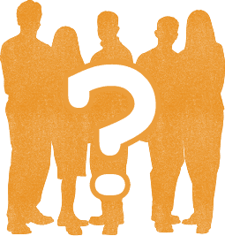
Revise it - Who’s who of Anglo-Saxon and Norman England?
Task 1- Use your work or the internet to explain who these famous figures were. The first one has been completed for you.
Individual | Who are they?
William I | William was Duke of Normandy. In 1066 he became King of England after winning the Battle of Hastings. William was a strong ruler who survived many rebellions. William died in 1087. Also known as William the Conqueror.
Edward the Confessor
Harold Godwinson
Edwin, Earl of Mercia
Edgar Aethling
Robert Cumin
William FitzOsbern
Harald Hardrada
Hereward the Wake
Archbishop Lanfranc
Queen Matilda
Morcar, Earl of Northumbria
Odo, Bishop of Bayeux
Robert of Normandy
Sweyn King of Denmark
Tostig, Earl of Northumbria
Waltheof
William Rufus
Archbishop Stigand
Challenge - The three below are all together for a reason
Roger, earl of Hereford
Emma FitzOsbern
Ralph Earl of Norfolk

Task 2 - Highlight all of the Saxons in one colour, the Normans in a second colour and Scandinavians (Sweden, Norway, Denmark) in a third colour.
Task 3 – If you needed to answer a question on the Godwins which names would you need to include? Write a list below.

Task 4 – If you needed to answer a question on the succession crisis in 1066 which names would you need to include? Write a list below. (Succession – who should be the next king).

Task 5 – If you needed to answer a question on the Saxon rebellions against William which names would you need to include? Write a list below.

Task 6 - If you needed to answer a question on The Revolt of the Earls in 1075 which names would you need to include? Write a list below.

Task 7 - If you needed to answer a question on William’s family which names would you need to include? Write a list below.

Task 8 – Now try to learn them and get others to test you. How many out of 20 can you remember?

