Chemistry Revision: Cells and Batteries
Mastery Matrix Points TRIPLE ONLY
Describe what a chemical cell is and list the factors that affect the voltage produced (triple only)
Describe what a battery is (triple only)
Describe rechargeable and non-rechargeable batteries and cells (triple only)
Interpret data for relative reactivity of different metals to evaluate the use of cells(triple only)
Describe what a fuel cell is (triple only)
Compare and contrast the use of hydrogen and chemical cells (triple only)
Write half equations for the electrode reactions in the fuel cell (triple only)

Key Knowledge

Definitions:
Chemical cell –

Battery –

Rechargeable batteries -

Non-rechargeable –

Fuel cell -

Alkaline batteries – rechargeable/
non-rechargeable?

Factors that affect the voltage produced by a chemical cell
-
-
-

Word equation for hydrogen fuel cell:

Half equation for anode:

Half equation for cathode:

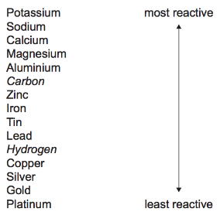
Understanding and Explaining
- Explain how a chemical cell produces electricity.

- Evaluate the pros and cons of using rechargeable batteries and non-rechargeable batteries.

- Explain which of these combinations of electrodes would produce the highest voltage (potential difference) in a chemical cell.
METAL 1 | METAL 2
Magnesium | Tin
Zinc | Lead
Copper | Nickel
Magnesium | Copper

- Explain how a hydrogen fuel cells works include the overall word equation and half equations for the anodes.

- Describe the pros and cons of hydrogen fuel cells compared to using a chemical cell (battery).

