Physics Revision: Atomic Physics
Mastery Matrix Points
Describe the structure and size of an atom
Calculate the number of protons, neutrons and electrons in an atom
Describe how electrons can change energy level
Describe isotopes
Describe what an ion is
Describe the development of the model of the atom (Plum-pudding, Rutherford, Neils Bohr and Chadwick).

Key Knowledge

Radius of an atom =

Radius of a nucleus is __________ times smaller than the atomic radius.

Label the parts of an atom:
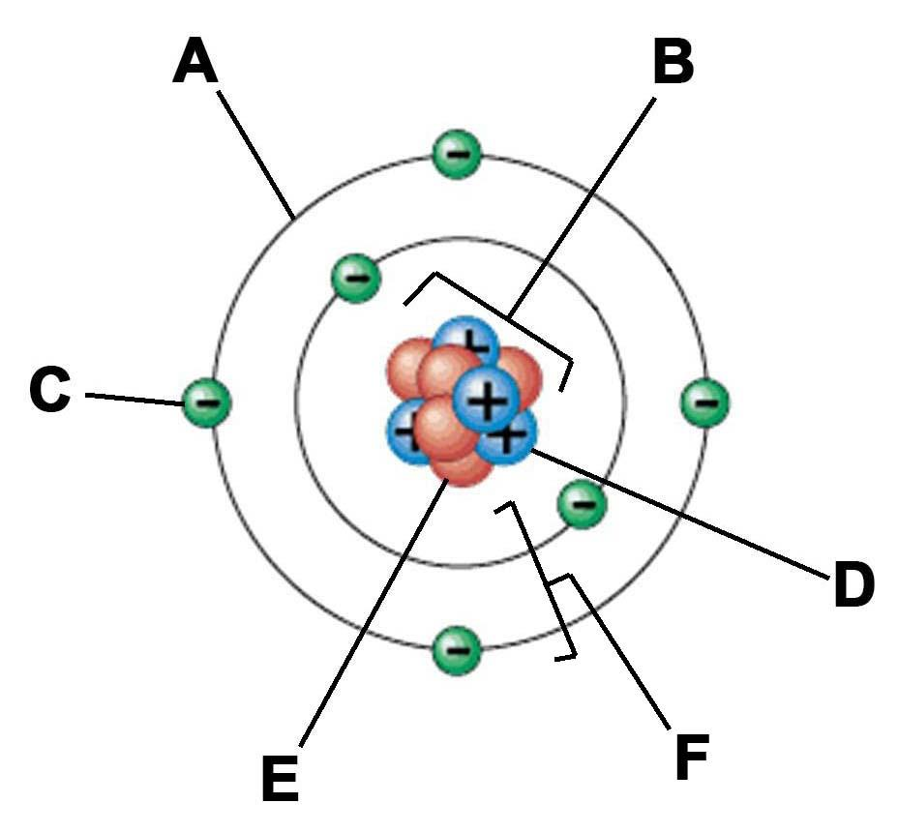

What order were the parts of the atom discovered?

Using the periodic table:
To find the number of protons…

To find the number of electrons…

To find the number of neutrons…

Definitions:
Isotope

Ion

Plum pudding model

Nuclear model

Understanding and Explaining
- Explain what would make an electron jump to a higher energy level.

- Explain what would make an electron fall to a lower energy level.

- Why might scientists make changes to an existing theory?

- Describe the alpha scattering experiment, its results and why the results led to a change in the theory of the atom.

- Explain the role of Niels Bohr in atomic theory.

- Describe the contribution of James Chadwick to atomic theory.

