**Physics Revision: Series and Parallel**

Understanding and Explaining

1. **Explain how to calculate the total resistance of a series circuit.**
2. **Calculate the total resistance of these components.**

**a) 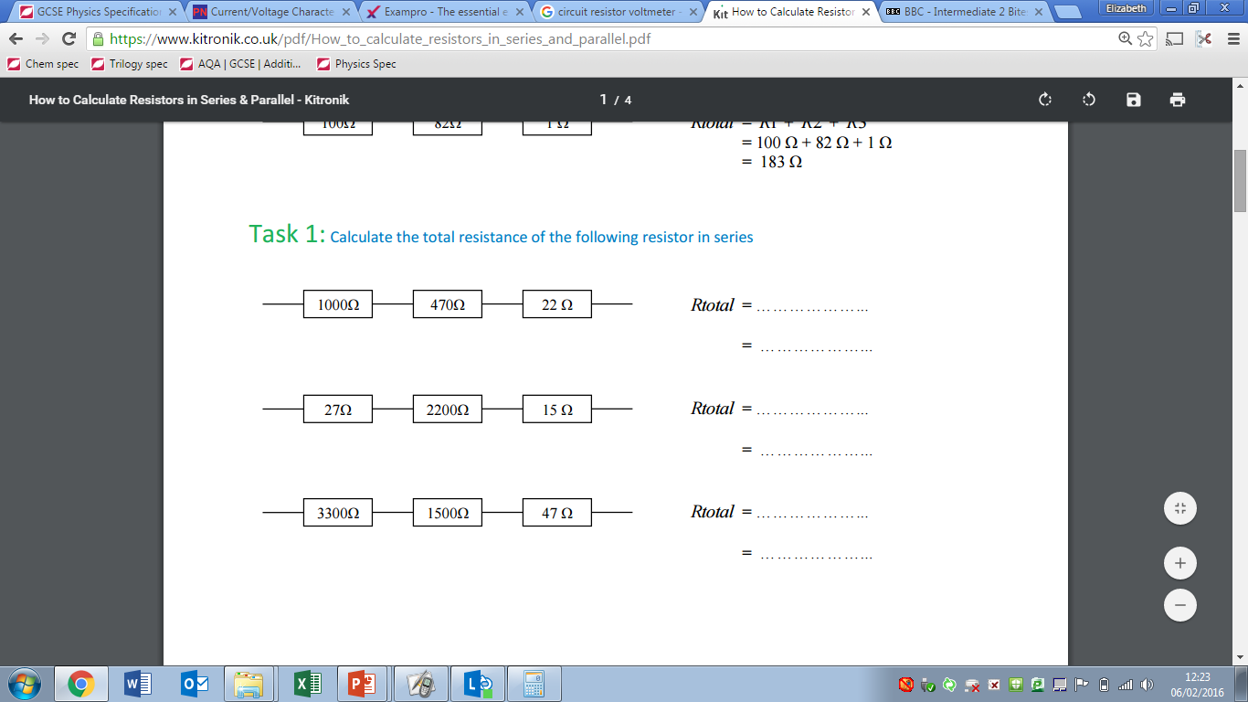b) **

**c)**

1. **Explain what the resistance will be less than in each of these circuits.**

a)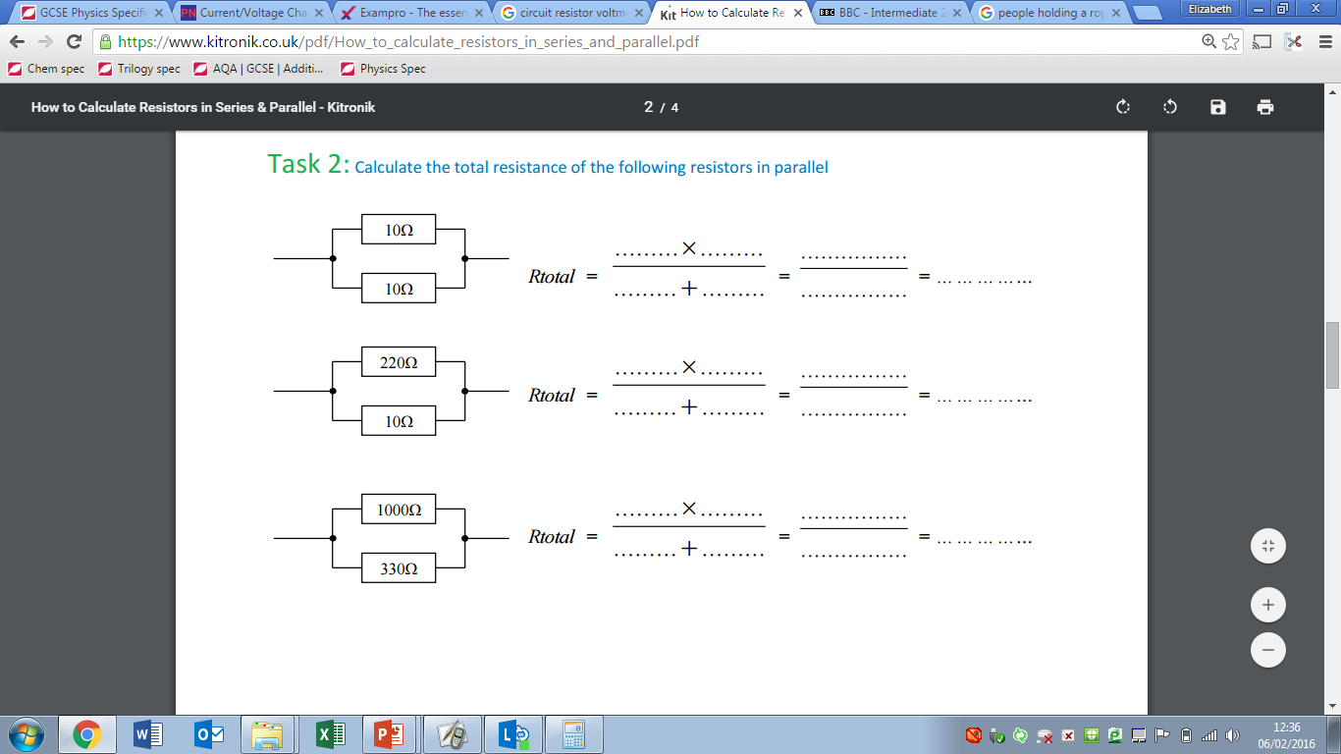b)c)

1. **Explain qualitatively why adding resistors in series increases the total resistance whilst adding resistors in parallel decreases the total resistance.**

Mastery Matrix Points

|  |
| --- |
| Compare and contrast series and parallel circuits |
| Calculate resistance in series and parallel circuits |
| Explain patterns in resistance using words |

Key Knowledge

Resistance definition:

Series circuits have…

Circuit diagram of a series circuit:

Parallel circuits have…

Circuit diagram of a parallel circuit:

In a series circuit:

Rtotal=

In a parallel circuit, the total resistance of two resistors is ____than the resistance of the

smallest individual resistor.

**Circuits**