2020 Year 11 ART AND DESIGN GCSE EXAM

Home learning: 2-3 hours every week.
Support: Exam club Mon and Fri lunch & THURS afterschool until 4pm
Extension work: Set with home learning
Planning: Specific 'planning and preparation' task set over Easter.

Exam preparation is worth 60 marks out of 80 so is 30% of your overall GCSE Art and Design grade.

Exam prep deadline:
The exam board require you to hand in your sketchbook, mood boards, design sheets and all preparation on:Thursday 7th May.You cannot take it home after this date.

Date | Lesson | Activity | Home learning/Exam planning | Notes/  Hwk dates
Mon 3rd Feb  Wk2  W55 | 1 | Exam launched with a Power Point of ideas.  - Give out exam paper discuss AOs and titles.  - Give out sketchbook, lesson planner, and mark sheet. Stick into sketchbook. Discuss HL expectations.  - Study the Illustrator/artist research inspiration from PowerPoint. Read information on the first few slides  - Choose exam title and start artist research.  Focus on OCR syllabus AO1:  Artist research & experimentation of initial ideas. 20 marks (10% of GCSE grade) | Hwk Artist 1: A study of 1 artist on larger A2 mood board or an A3 double page in sketchbooks. Artist must have a coloured test piece of artists work. NB: Artist: Painter, Designer, Sculptor, Cultural topic, Photographer, Illustrator, Fashion designer. | For Thurs 13thFeb
Thurs 6th Feb  Wk2  &  Mon 10th Feb  Wk1  W55 | 2,3 &4 | - Individual research. Focus on building up research to include background information and images on a range of varied artist on chosen exam title.  - You will be studying 4 of these artists in more detail in class and for home learning.  Extension: Use the image research sheet to find images, pictures, photos, objects and backgrounds that will enable you to develop observation work for you exam project.  Fill in mind map for artists section on sheet with teacher | Challenge work: Produce own design or observation using own images inspired by the style or concept of artist
Thurs 13th Feb  Wk1  W55 | 1 | IMAGE RESEARCH: Use the image research sheet to find images, pictures, photos, objects and backgrounds that will enable you to develop observation work for you exam project. These will be initial images you can add to at a later date.  LAST LESSON TO RESEARCH IN W55 | HWK IN
Half Term home learning 2: For Monday 24th Feb.
A study of 1 artist on A2 mood board or 2 artists on 2 A3 double pages in sketchbook. Each artist with a coloured test piece of artist style. NB: Artist: Painter, Designer, Sculptor, Photographer, Illustrator, Fashion designer.

Development and challenge: One artist can be an experimental 3D presentation: Box, 3D object, customised object, piece of graffiti, mock up magazine or newspaper, booklet, leaflet. ( see examples)

Challenge work: Produce own picture or design using own images inspired by the style or concept of artist with own personal comments of how the idea links to the exam question.

Mon 24th Feb  WK2 | 5 | Artist 3  Focus on one artist: Develop the A4 test piece a copy of artist work using appropriate media. Experiment with colour, style and imagery of artist | HWK IN
Thurs 27th Feb  WK2 | 6 & 7 | Artist 3  Mount up and present artist 1 with:  - Own test piece.  - Information.  - Examples of the artists’ work | .
Mon 2nd March  Wk1 | 8 | Artist study 4  Artist/ Illustrator Research- Develop artists work with own personal developments. Ideas………  - One more A3 mood board. With information, range of images and a test piece of artist, illustrator designer’s work  - Presentation of images and research linked to artist or a cultural/contextual link.  - A4 copy of artist work. | HWK:Work on targets set and attend club or lunchtimes to catch up if absent | For Thurs 12th March
Thurs 5th March  Wk1  &  Mon 9th March  Wk2 | 9 & 10 | Artist study 2  1. Focus on the coloured test piece to complete in full detail.  2.Mount up and present artist 1 with:  - Own test piece.  - Information.  - Examples of the artists’ work  For next lesson you need to have 2 or 3 different coloured printed images or photos.  You can project or draw. Save them or put on pen drive ready as well. |  | End of A01:Artist research & experimentation of ideas  20 marks (10%)
Thurs 12th March | 2 & 3 | Observation. Students develop own work using observation or images:  - Each student takes it on turns to project on image to A4 or A3 to develop in detail in pencil using shade, cross hatch and stipple.  - Observation study-small detailed finer liner drawing/biro or pencil crayon on sugar paper of observed object or image. Use techniques such as half and half and squared drawing to support observation.  - Oil pastel study, mixed media or acrylic. Work on collage surface? Enlarged image. Work on over two lessons  Focus on OCR syllabus AO3:  Image research, photos, observation & media development.  20 marks (10%) | HWK: A3 or A2 observation and image mood board:  Observation work, quick sketches, continuous line, fine liner, coloured studies, detailed drawings, images in style of artists, working on top of surfaces (coloured paper, envelopes, sheet music, inks) pictures based on exam theme.  Include BACKGROUND IDEAS | For Mon 23rd March
Mon 16th March  Wk 1 | 4 | Observation. Students develop own work using observation or images. Starting with detailed A4 or A3 pencil study | Challenge: Own Photography for exam project
Thurs 19th March Wk1  Mon 23rd March  &  Thurs 26th March  Wk 2 | 5,6,7 & 8 | Complete below  1. A3 observation to develop in detail in pencil using shade, cross hatch and stipple.  2. Possible small observation study-detailed finer liner drawing/biro or pencil crayon on sugar paper of observed object or image.  3. Or oil pastel study or acrylic on collage surface observed enlarged image. Work on over two lessons  Look at the mock up collage examples of thumbnails. How can we create ideas through collage as a contrast to drawn thumbnail ideas? If students want to use their images to collage they need to colour photo copy a range of their own artwork. | HWK IN
Mon 30th March  Wk1  Thurs 2nd April Wk1 | 1& 2 | Thumbnail ideas:  1. Draw out 4-6 thumbnail ideas for ideas for the final piece using the help sheets.  2. Using photocopied artwork create collages of designs and developed picture layering your images, pictures and text.  Focus on OCR syllabus AO2:  Refinement of ideas and media testing. 20marks (10%) | Check understanding of Easter exam prep task.  Get all materials, paper and folder ready for prep over Easter
EASTER EXAM PREPARATION TASK: Monday 20th April

MAIN EXAM TASK: ALL STUDENTS MUST COMPLETE THE FOLLOWING for THE FIRST LESSON BACK AFTER EASTER:

2 detailed ideas inspired by an artists’ colours, style, techniques or imagery:
- Drawn out in full detail on A3 paper observing images carefully.
- Include background and main images/text.
- Produce full section in colour using choice of media.
- Annotate to explain idea in terms of artists inspiration and your response to exam title.
Challenge: Complete additional sections of the final design in colour or half the design. You can test the section in a different colour range.

Mon 20th April  Wk2 | 3 | IDEA 3: Complete A3 picture or design inspired by an artist as a final idea:You can use inspiration from  - Images or symbols.  - Style or techniques used.  - Colour combinations (the use of contrasting colours?)  - The concept of idea of the artist.  Draw out the design in full detail. | HWK IN | End of AO3:  Image research, obs & media development.  20 marks (10%)
Thurs 24th April  Wk2 | 4 &5 | Now add detail, colour and refinement to a SECTION of the design in colour remembering to:  1. Refer to original printed images.  2. Incorporate an element from one of your artist.  3.Use your creativity and imagination
Mon 27th April  Wk 1 | 6 | Last lesson on IDEA 3  Now complete the detail, colour and refinement to a SECTION of the design in colour.
Thurs  30th April  Wk 1  & Mon 4th May  Wk2 |  | Review all design ideas and select final design 1,2 or 3 to develop as a final piece or design. Start final piece plan.  Final design mood board- 6 Hours: A2 presentation.  Show exemplar design boards:  - Use one of your ideas as the final plan in full detail with a test section in FULL COLOUR.  - Do you need to complete a larger test.  - You could include a collage of the images that have inspired you for the final design.  - Include pictures or illustrations by the artist or illustrator who has inspired the concept, design, style or colours of your final piece.  - Add personal comments to explain the development of your piece, how it links to the exam question and decorate the presentation. | HWK: Spend 2-4 hours on the final design plan.  Complete final design plan.  PROJECT/ DRAW OUT FINAL EXAM PIECE 20 mins- Mrs Wycherley must keep this for the exam.  LAST LESSON BEFORE THE ART PRACTICAL EXAM. | Use lunchtimes and after school club to also project final piece ready for WEDS 7TH MAY  End of AO2:  Refinement of ideas and media testing.  2O marks (10%

EXAM DATES- Final piece 10 hour design: A04-10%

Wednesday 7th May | all day – 8.45 am - 3.05  (normal break time and lunch)
Thursday 8th May | all day – 8.45 am - 3.05  (normal break time and lunch)
Monday 12th May | Absentee period.

EXAM INFORMATION

- You will complete your 10 hour final design in the exam sessions.

- Remember you can prepare materials and equipment for the exam E.g. cut out stencils, trace text, cut up/ rip collage.

- Objective 4: Final piece- 20 marks out of 80 and 10% of the GCSE

INSPIRATION

BBC Bitesize Art and Design (http://www.bbc.co.uk/schools/gcsebitesize/art/) gives you a few good tips for GCSE art especially the section on CREATIVE PROCESS.

Exam PowerPoint: Use the artist’s power point I have provided as a starting point. This can be found on the L DRIVE in students resources accessed via RM unify. Use the sticker in your planners that show you how to access the school system at home.

Illustrationdirectory is a great website for creative illustrators to inspire you. Type in a key word or exam title in the search engine.

Pinterest is great for sharing ideas and has lots of ‘PINS’ for the exam titles.

Fineartamerica is a great website for painters and photographers to inspire you. Type in a key word or exam title in the search engine.

BE PREPARED- Tips for success

~ Check on classwork/home learning if you are absent during lesson time in Feb-April.

~ Bring your work to every lesson and always complete home learning on time.

~ Come to see EJW/RL anytime if you are uncertain about your work or the idea for your final piece.

~ Bring your sketchbook and all preparation to the first exam session. Make sure you have drawn out and planned your final piece in detail.

Work hard especially over half term the Easter break but remember to include some chill out time as well. Think about the long summer holiday ahead of you after all the exams have finished.

………………………………………………GOOD LUCK…………………………………………………………

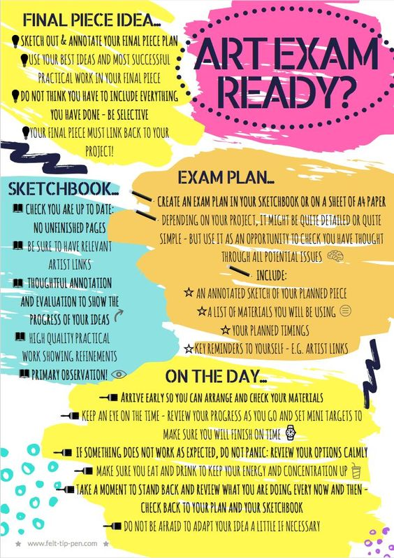

on sheet of A2 Paper

