Unit 1 – The origins of the Cold War to 1945 | Road Map - Year 12 ‘The Cold War in Europe 1941-1995’
In this introductory unit you will have the opportunity to study the roots of Cold War Hostility; from the Russian Revolution to the tensions within WWII’s Grand Alliance against Hitler. The aims are as follows:  LG1: Knowledge  LG2: Application  LG3: Skills | Assessments | Grades
Themes | Learning Goals/Outcomes/Content
1)Key Question– So what is A Level History?

2) Key Question– Was the Cold War an inevitable result of a clash of ideas? | LG1 – Build your knowledge of the differences between Communism and Capitalism and why they were viewed as mutually exclusive for most of the 20th Century.  LG2 – Apply your knowledge of ideology to decide to what extent ideology made the Cold War inevitable.  LG3 – Causation and Interpretation
3) Key Question– What was the most important long-term cause of the Cold War? | LG1 – Build your knowledge of the long-term causes of the Cold War.  LG2 – Apply your knowledge of the long-term causes of the Cold War to evaluate their significance based on impact.  LG3 – Causation and Importance
4) Key Question– Why did tensions begin to emerge in the Grand Alliance 1941-1945? | LG1 – Build your knowledge of the conflicting aims of the Big Three.  LG2 – Apply your knowledge of the aims of the Big Three to analyse and evaluate the issues that would be most instrumental in deepening suspicion and mistrust within the Grand Alliance.  LG3 – Interpretation and Causation
5) Key Question - What do the war conferences reveal about the tensions and difficulties between the Superpowers? | LG1 – Build your knowledge of the terms and aims of the conferences.  LG2 – Apply your knowledge of the war time conferences to explain how they contributed to growing tensions between the Western powers and the USSR.  LG3 – Causation and Importance
6) Key Question–  How far did the liberation of Europe at the end of World War II cause the Cold War? | LG1 – Build your knowledge of the main features of the liberation of Eastern Europe – including the pattern that Soviet liberation took as well as national variation.  LG2 – Apply your knowledge of the liberation of Eastern Europe to evaluate to what extent the methods used caused the Cold War.  LG3 – Causation and Importance
7) Key Question - How far was Harry Truman responsible for the break down of the Grand Alliance? | LG1 – Build your knowledge of Truman’s personality, approach and policies.  LG2 – Apply your knowledge of Truman to analyse the impact he had on the early stages of the Cold War.  LG3 – Causation and Importance
Links:
This first unit focuses on the long-term causes of the Cold War – the clash of ideologies, early conflicts between communist Russia and Western democracies, the impact of World War II, tensions at the war time conferences, the Soviet liberation of Eastern Europe and the role played by new personalities in 1945. Key history skills such as causation, importance and interpretation will shape this unit.

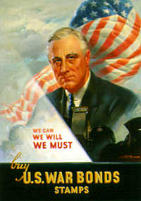
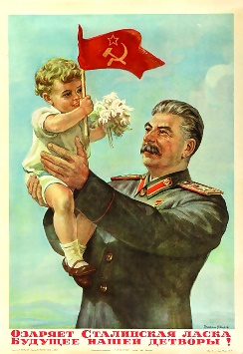
Oldbury Wells Humanities Faculty
The Cold War in Europe 1941-1995
The origins of the Cold War to 1945
 | How well have I understood this?
Topic | Not at all | Not well | OK | Well | Very well
- Capitalism Vs Communism
- Pre-war tensions from 1917
- The situation in 1941
- War time tensions
- Post war aims
- Conferences (Tehran,Yalta,Potsdam)
- The liberation of Europe
- Relations between the Big Three

Feedback - WWW/EBI
WWW

EBI

Further ideas for improvement, extra reading etc.

