Unit 4 – The end of the Cold War 1984-1995 | Road Map - Year 12 ‘The Cold War in Europe 1941-1995’
In this unit you will study how long term economic and social pressures on the Soviet Union combined with new international leaders and growing Eastern European Nationalism brought about the end of Communism in Europe and the collapse of the USSR. This didn’t however mean peace as violence and genocide erupted in the former Yugoslavia. The aims are as follows:  LG1: Knowledge  LG2: Application  LG3: Skills | Assessments | Grades
Themes | Learning Goals/Outcomes/Content
1)Key Question– What were the economic and social problems facing the USSR in the 1980s? | LG1 – Build your knowledge of the challenges facing the USSR and it’s new leader – Mikhail Gorbachev.  LG2 – Apply your knowledge of the challenges to understand the solutions attempted by Gorbachev.  LG3 – Causation
2) Key Question– What was the impact of Gorbachev’s New Political Thinking? | LG1 – Build your knowledge of the policies of glasnost, perestroika and arms reduction  LG2 – Apply your knowledge to assess the impact of Gorbachev’s ‘New Thinking’.  LG3 – Causation, Importance and Interpretation
3) Key Question– How significant was popular protest in bringing about an end to Soviet control over Eastern Europe? | LG1 – Build your knowledge of the role played by popular protest in the collapse of Communism in Eastern Europe.  LG2 – Apply your knowledge to evaluate the extent to which popular protests brought about change in Eastern Europe.  LG3 – Causation and Importance
4) Key Question– How did the Cold War in Europe end? | LG1 – Build your knowledge of the final steps in the reunification of Germany.  LG2 – Apply your knowledge to explain the significance of the reunification of Germany in ending the Cold War.  LG3 – Causation and Importance
5) Key Question– Why did the USSR disintegrate? | LG1 – Build your knowledge of the stages and factors that led to the collapse of the USSR  LG3 – Causation
6) Key Question - How significant was Yeltin’s contribution to the collapse of Communism in Russia? | LG1 – Build your knowledge of how Russia changed under Boris Yeltsin.  LG2 – Apply your knowledge to explain the significance of Yeltsin’s role in preventing the 1991 Coup and his later presidency.  LG3 – Importance
7) Key Question - Why did the collapse of the USSR lead to war and the break up of Yugoslavia? | LG1 – Build your knowledge of the causes and events of the Yugoslavian civil war.  LG2 – Apply your knowledge to explain how far the end of the USSR and the Cold War lead to conflict in Yugoslavia.  LG3 – Causation, Consequence and Importance.
8) Key Question - How have key moments of the Cold War been interpreted by historians? | LG1 – Build your knowledge of how key moments of the Cold War have been interpreted by different ‘schools of history’.  LG2 – Apply your knowledge to evaluate the accuracy of different interpretations.  LG3 – Interpretation.  Links:  This unit draws from earlier work on the challenges and weaknesses inherent in Communist economic policy, as well as the impact of the arms race. The role that new leaders played in the end of the Cold War will be built upon when considering in greater depth the significance of Mikhail Gorbachev and the abandonment of earlier Communist policies like the Brezhnev Doctrine. This unit ends in a review of key moments from the course and how they have been interpreted – leading you to looking in greater depth at historical interpretations in your new unit – your coursework.

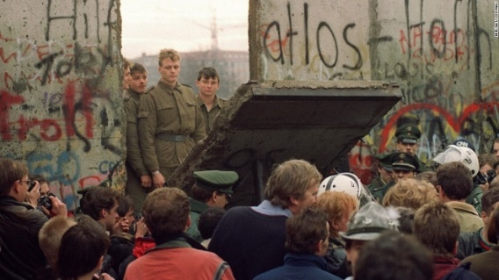

Oldbury Wells Humanities Faculty
The Cold War in Europe 1941-1995
The end of the Cold War 1984-1995
 | How well have I understood this?
Topic | Not at all | Not well | OK | Well | Very well
- Economic and social problems in USSR
- The pressure of the Arms Race
- Invasion of Afghanistan
- Poland
- Reagan
- Gorbachev (glasnost and perestroika)
- Collapse of communism
- Russia under Yeltsin
- End of the USSR
- Civil War in Yugoslavia to 1995
- Interpreting the Cold War – The Big Questions!
Feedback - WWW/EBI
WWW

EBI

Further ideas for improvement, extra reading etc.

