Medicine through time, c1250-present
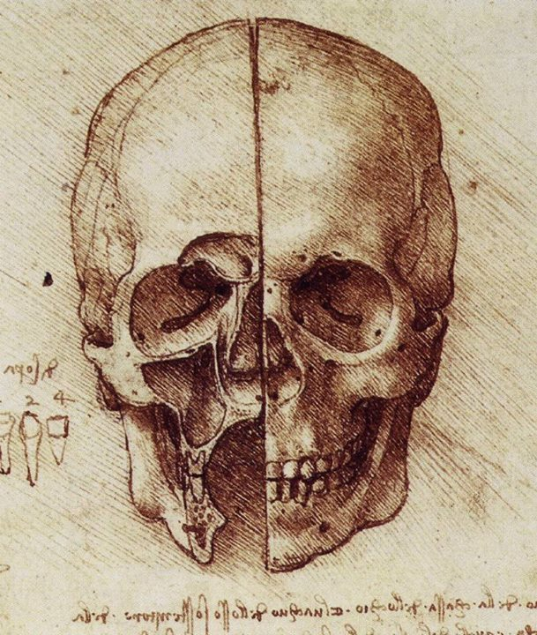
30% of your overall GCSE grade
Combination of sources (section A – British sector) and own knowledge (section B)
Name:
Teacher:

What do I need to know for the exam?
How do I revise?

Key Topic 1: c1250–c1500: Medicine in medieval England
What factors influenced the ideas about the causes of disease?
The Church | The Church did not like change and wanted to keep things the way they were. The Church controlled medical learning and it chose which books were copied and distributed. Church strongly discouraged anybody from criticising the Theory of the Four Humours.
Science and technology | A lack of scientific understanding meant that new knowledge was limited. Physicians and medical students tried to make new discoveries fit into the old theories, rather than experimenting to explain the discoveries.
Attitudes in society | Medieval people had a strong belief in God and did not want to risk going to hell by being critical of the Church. Many people believed that, since medicine had always been done this way, there was no need to change it
Individuals | Galen and Hippocrates were important individuals in the Middle Ages. Galen in particular was popular with the Church, which meant that his work was widely promoted.
Government | Did not spend any money on medicine, and therefore there was no money for medical breakthroughs

Key Topic 1.2 Approaches to treatment and prevention 1250-1500 Overview: What factors worked together to inhibit (prevent) change in medical thinking between 1250-1500?
THE CHURCH: extremely rich because it owned a great deal of land in every country. It was very powerful because they had a priest in every village and a bishop in every region. Through its bishops and priests it controlled education.
- The Bible said that God controlled every aspect of life so it was logical that God sent diseases. Believed that God also sent the Black Death as a punishment. If God sent diseases this meant that they were was no need to look for other causes.
- The Pope, bishops and priests told people that everything in the Bible was true and you could not challenge what the Bible said. If anyone did dare challenge the Bible and the Church they were told they would go to Hell when they died. People believed that Hell was a real place where they would suffer eternal pain from punishments such as being roasted over fires. This was a real fear which meant that hardly anyone dared to challenge what the Church said.
- The Church supported the ideas of Galen. Galen had not been a Christian but he had said that the body had been created by one God who made all the parts of the body fit together perfectly. The Christian Church said that God had created human beings and did not make mistakes so the two ideas fitted together perfectly. Church supported Galen’s work and this meant that no Christian dared to question Galen’s ideas.

EDUCATION: Church controlled education, including how physicians were trained at universities. There were in fact very few physicians in England as training took seven years and not many people could afford it. The main part of doctors’ training was reading the books of Hippocrates and Galen. Doctors were taught to believe what Hippocrates and Galen said, which meant that they were not encouraged to experiment or think for themselves. Dissections were another way of demonstrating that Galen’s descriptions of the human body were correct. The trainee doctors watched a surgeon carry out a dissection while a section of Galen’s book was read aloud. This meant that hardly anyone tried to find out more about the structure of the human body or how it worked.

ATTITUDES – RESPECT FOR TRADITION: the result of the Church and of the way doctors were educated was that most people had great respect for the past and for traditional ideas. They wanted to keep everything as it was (conservative attitude). This meant that it was hard for new ideas to spread because books were written out by hand. Doctors were not trained to challenge existing ideas.

INDIVIDUALS: No individual made a great breakthrough in the Middle Ages because education was very limited and controlled by the Church which did not encourage new ideas. The key individuals were therefore Hippocrates and Galen who had died centuries before. Galen, unlike Hippocrates, thought it was very important to dissect dead bodies to find out more about anatomy and about how the body works. Galen and Hippocrates ideas were believed as there seemed to be evidence to prove their ideas were correct and they covered everything in detail. Their ideas seemed logical and reassuring if you were sick.

GOVERNMENT: In the Middle Ages, the King’s government did not want to improve medicine. Kings did order for towns to be cleaned but they did not do this regularly. No taxes were collected which meant there was no money for medical breakthroughs.
Answer these quick fire questions to test your understanding
- Who came up with the Four Humours theory?
- What were the Four Humours?
- How would you treat somebody that had a temperature because of too much blood?
- Arguably, what was the most important institution in the medieval period?
- How did they use religion to explain the causes of disease and illness?
- How would a physician use star charts to explain the causes of disease and illness?
- How did bad air (miasma) explain the causes of disease and illness?
- What did physicians do with urine samples?
- Where did most people’s education come from during the Middle Ages?
- Who controlled education during the Middle Ages?
- Why did the Church lead to little change in medicine c1250-c1500?
- What would happen if you challenged the Church’s teaching?
- Whose ideas did the Church support?
- What was the main part of doctors’ training?
- What does it mean to have ‘conservative’ ideas?
- Why was there no medical breakthroughs during the Middle Ages?

- What year did the Black Death hit Britain?
- Give three causes of the Black Death
- Give two treatments of the Black Death
- How did people try and prevent the Black Death?
- What role did the government play in helping with the Black Death?

Key topic 2: The Medical Renaissance in England 1500-1700
2.1 Ideas about the causes of disease and illness
Renaissance means rebirth and this period in European history saw a ‘rebirth’ of old ideas from Ancient Greece and Rome. People began to question, challenge and test assumptions. They started to slowly break down old beliefs and rethink the way the world worked. The Protestant reformation was challenging the teachings of the Catholic Church. Scientists started to provide evidence that the Greek teachers were wrong. However, some things stayed the same.
Ideas about the causes of disease and illness that stayed the SAME between 1250-1700 | Ideas about the causes of disease and illness that CHANGED between 1250-1700
Theory of miasma continued to be believed by many to be the cause of disease. It was popular during epidemics. Miasma was the product of rotten vegetables, decaying human bodies and excrement  The Theory of the Four Humours continued to be accepted explanation for disease, BUT… by 1700 very few physicians still believed in it  Supernatural explanations | Gradually, fewer people believed in supernatural or religious causes of disease  New rational explanations for disease were suggested – seeds in the air spreading disease  Reduced influence of the Church and a move towards a scientific approach to diagnosing illness  Urine analysis no longer used as physicians now understood that urine was not linked to ill health

2.2. Approaches to prevention and treatment 1500-1700
Treatment
Change from the Medieval period | Continuity from the Medieval period
Transference – illness/disease could be transferred to something else. People believed if you rubbed an object on an ailment, the disease transferred to the object  New herbs started to appear from other countries. Appearance of new remedies opened up a huge number of possibilities for treatments and cures. Sydenham popularised the use of cinchona bark from Peru in treating malaria.  Growth of alchemy meant that people began to look for chemical cures for diseases instead of relying on herbs and blood-letting. New science was known as iatrochemistry (medical chemistry)  Pharmacopoeia Londinensis was published by the College of Physicians in 1618 as a manual of remedies were 122 different chemical preparations including mercury and antimony – promotes sweating so cools the body down. | Belief in humoral treatments persisted. Old treatments aimed at rebalancing the humours continued. Bleeding, purging and sweating were all popular ways of removing too much of a particular humour  Herbal remedies continued to be popular. 1500-1700 remedies were chosen because of their colour/shape. For example, saffron used to treat jaundice

Prevention
Change from the Medieval period | Continuity from the Medieval period
No change in preventing disease – only way to avoid dying was to avoid catching the disease  Condition at birth was important – if you were born small then it could be used to explain death from an illness  Cleanliness was still important in the home and the body  Still practiced the regimen sanitas | Bathing had become less fashionable since the spread of syphilis – people believed that bathing led to diseases. More likely to now keep themselves clean by rubbing themselves down with linen and changing clothes regularly  Certain weather conditions or surrounding atmosphere spread disease.  More steps were taken to remove miasma – punishment given to minor criminals (picking up rubbish from the streets)

Medical care
Change from the Medieval period | Continuity from the Medieval period
Education increased considerably. Wars were being fought with new technology, new wounds on battlefields meant more surgery was needed.  Introduction of iatrochemistry introduced new ingredients into the stores of the apothecaries. Now had to possess licenses to practice their trade  New subjects were introduced into the medical curriculum – iatrochemistry/anatomy  Doctors inspired to challenge the old teachings and investigate for themselves.  Dissection was legalised (previously been banned by the Church)  Trainee doctors had much better access to medical textbooks – printing press made these cheap to print  Protestantism rejected highly decorated Churches, artists found themselves out of work, so they created detailed drawings for these new medical textbooks. Individual pictures available. | Apothecaries continued to mix remedies and surgeons carried out simple operations.  Surgeons and apothecaries continued to provide a service for those unable to afford physicians. Physicians continued to be trained at universities – training courses changed very little. Most learning still from books  Still very little, practical hands-on training

Caring for the sick
Change from the Medieval period | Continuity from the Medieval period
Hospitals began to change – records suggest that many people went to hospital with wounds and curable diseases and they did not spend long in hospital – got better  Good diet whilst in hospital. Visit from a physician twice a day and hospitals started to have their own pharmacies  Many hospitals reopened without their religious sponsor  Pest houses started to pen – specialised in a particular disease  Hospitals now offered a much needed service – traditional hospitals would not admit patients who were contagious | Most sick people still cared for at home  Women plated a really important role  Women popular as they were cheaper

Answer these quick fire questions to test your understanding

- What is meant by the Renaissance period?
- Give 2 key ideas that changed from the Middle Ages to the Renaissance period
- Give 1 key idea that stayed the same from the Middle Ages to the Renaissance period
- Who was Thomas Sydenham and how did he change the way of thinking with regards to how diseases and illnesses spread?

- What was created in 1440 that led to information spreading more quickly and accurately?
- Who were the Royal Society and how did their work gain credibility?
- How were more steps taken to remove miasma during the Renaissance period? What started happening for the first time?

- Why did training improve for doctors and medical professions? What did they have much greater access too?

- What year did the Plague hit London?

- Give one new method of trying to treat the symptoms of the Plague?

- How did people try and prevent the Plague

- Give two ways in which the government/king tried to help

Key topic 3: The Industrial Revolution 1700-1900
3.1 Ideas about the causes of disease and illness
Overview
- Four Humours was no longer widely believed
- Bleeding/purging were common treatments
- Apothecaries still sold herbal remedies, women carried out treatments at home
- Epidemics like the plague disappeared, but smallpox was a very common illness
- In the 19th century germs were discovered, which altered the ideas about the causes of disease and illness
- Jenner developed the first vaccination
- Surgery was less dangerous – hospitals became cleaner
- Scientific revolution was happening alongside the Enlightenment – society was changing, cities started o grow
- The Enlightenment – idea people could think for themselves, and the Church could not control everyday life
- People still believed in miasma, but it was becoming less popular

3.2 How did treatment and prevention methods develop during the 18th and 19th centuries?
There was CHANGE in the way people were cared for and treated | There was CONTINUITY in the way people were cared for and treated
People started to realise infection was everywhere – dirty clothes, medical instruments and unwashed hands.  Government was more willing to take steps to prevent disease spreading | Took a while for medical science to catch up with the new ideas of causes  Still not a good understanding of how to remove germs  Old herbal remedies continued to be popular  Prevention was the most important aspect – more widespread

Overview: Why were there so many medical breakthroughs during the 19th century?
- INDIVIDUALS: there were a number of key individuals in this period that allowed for medical breakthroughs. Each one worked together using each other’s work to develop and investigate how to explain the causes of disease. Koch had developed Pasteur’s work on Germ Theory, and then when Koch published his work on bacteriology, John Snow’s work made sense and the government accepted it. Jenner was willing to experiment thus allowing him to make the first vaccination

- GOVERNMENT: more willing to spend money to improve public health because more people had the vote, and therefore they had to appeal to the wider audiences. The 1848 and 1875 Public Health Acts were landmark years as the government took responsibility for public health. The 1875 Public Health Act was more significant because it forced local councils to improve public health facilities. The government also gave Jenner £30,000 to develop his work on vaccinations in 1802 and 1807. They made vaccinations compulsory and enforced fines for failing to vaccinate children, which led to a steep fall in the number of smallpox cases

- TECHNOLOGY: The Industrial Revolution was an exciting period of change and developments in medicine were greatly helped by improvements in technology that resulted from the Industrial Revolution. Many pieces of scientific and medical equipment improved because industries developed the ability to create more precise equipment. The most significant development was the microscope which allowed scientists to see and identify bacteria for the first time. Lister developed a microscope that magnified things 1000 times. The sewer system was also built in London – required machinery powered by steam engines.

- ATTITUDES: starting to change – there had to be a scientific explanation for why people were getting ill. Fitted in with the ideas of the Enlightenment. Doctors were increasingly trained to use scientific methods and doctors were trained more professionally.

Answer these quick fire questions to test your understanding
- Who was the first person to develop vaccinations?
- What was discovered in the 19th century to be the true cause of illness?
- Which individual discovered Germ Theory?
- Give one reason why Germ Theory had a positive impact in Britain?
- What did Robert Koch discover?
- Why did Koch’s discovery have a positive impact?
- What did John Snow conclude about cholera?
- Who was sent to the Crimean to improve conditions in which soldiers were treated in?
- Give two ways in which this individual helped the soldiers
- What impact did this person have on hospitals in Britain?
- Who made the link between smallpox and cowpox?
- Briefly describe this persons discoveries
- Give two positive impacts of the vaccination
- Give two negative impacts of the vaccination
- How did the government start taking more responsibility for people’s health?
- Why did they do this?
- What did James Simpson discover that helped improve surgery?
- Why was Joseph Lister significant in helping improve surgery?
Key topic 4: Modern medicine, 1900-present
  - Ideas about the causes of disease and illness
Overview
- By 1900, Germ Theory had been around for nearly 40 years
- Microbes had been linked to outbreaks of disease e.g. cholera/diphtheria
- 20th century = no longer referring to miasma, the Four Humours or supernatural causes when diagnosing illnesses
- Now had solid, evidence-based knowledge
- During the 20th century, move towards laboratory medicine – more examination of samples (e.g. skin/blood/biopsies), examined by the labs, using microscopes and technology
- Patients could be x-rayed to allow doctors to see what was going on inside the body
- Diagnosis was now much more accurate – exact microbe could be identified and targeted
- Biggest change of diagnosis in the 20th century was that t was now based on medical testing

- Development of machines and computers has enabled doctors to have a better understanding of a patient’s symptoms
- X-rays and CT scans mean doctors no longer have to use surgery to diagnose all disease
- Enormous leap forward in technology since 1900 has made diagnosing disease much more accurate
- This has allowed for doctors to be able to treat patients

Answer these quick fire questions to test your understanding
- What was the biggest change that took place in diagnosing disease and illness in the modern period? What was diagnosis now not based on?

- What was discovered in 1953 that helped explain hereditary diseases?

- Which pair of individuals claimed they had discovered the secret of life?

- How does lifestyle and health factors contribute towards causing diseases and illnesses?

- What is a magic bullet?

- Which individual experimented with petri dishes and discovered penicillin by chance?

- Which pair of individuals then tried to mass-produce penicillin?

- What year was the NHS launched?

- Why was this a significant breakthrough in the treatment and care of the population?

- In what ways have the government helped prevent disease? Give two examples

- What is the second most common cancer in the UK?

- How is this cancer diagnosed?

- How have the government tried to change people’s behaviour with regards to preventing this cancer?

- What similarities are there between cholera and this case study with regards to how the government reacted?

What will my exam look like?
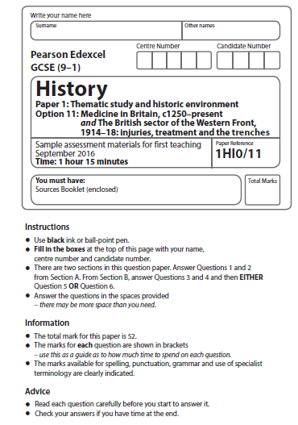

Section A: The British sector of the Western Front, 1914-1918: injuries, treatments and the trenches
- 3 questions
- 1 x describe question (4 marks – same as Elizabeth)
- 1 x source utility (8 marks – same as Germany paper)
- 1 x follow-up source question
Q1) Describe two features of… (4 marks – 5 minutes)
- Aseptic surgery in the early 20th century

- The trench system

- The effects of gas attacks

- Chain of evacuation process

- Trench illnesses

- The methods used to reduce the risk of trench foot

- The weapons used on the Western Font that caused severe wounds to soldiers

- The trenches that led to ill health

- Support trench system on the Western front

- of the effects of poison gas attacks on soldiers

- Blood transfusions

Q2) How useful are sources A and B for an enquiry into…. (8 marks – 12 minutes ish)
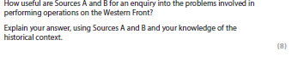
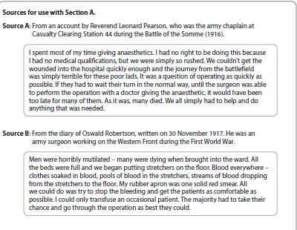
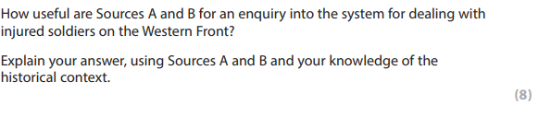
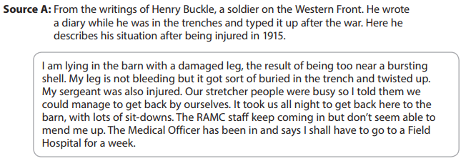
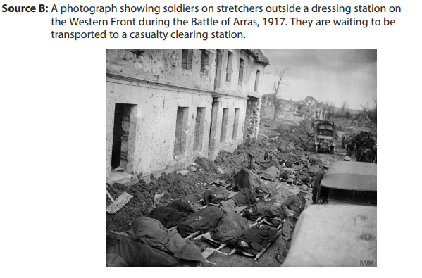
How useful are Sources A and B for an enquiry into the effects of gas attacks on the Western Front? (8 marks)
- Gas!Gas! Quick, boys! – An ecstasy of fumbling,
Fitting the clumsy helmets just in time;
But someone still was yelling out and stumbling,
And flound'ring like a man in fire or lime . . .
Dim, through the misty panes and thick green light,
As under a green sea, I saw him drowning.
In all my dreams, before my helpless sight,
He plunges at me, guttering, choking, drowning.
If in some smothering dreams you too could pace
Behind the wagon that we flung him in,
And watch the white eyes writhing in his face,
His hanging face, like a devil's sick of sin;
If you could hear, at every jolt, the blood
Come gargling from the froth-corrupted lungs,
Obscene as cancer, bitter as the cud
Of vile, incurable sores on innocent tongues,
My friend, you would not tell with such high zest
To children ardent for some desperate glory,
The old Lie; Dulce et Decorum est
Pro patria mori. (Means it is sweet and glorious to die for your country)
Source A: From Dulce et Decorm Est, a poem written by Wilfred Owen in 1917 whilst he was being treated for shellshock. He served on the Western Front in 1916-1917 and returned to 1918. where he was killed in action shortly before the end of the war
Chlorine gas destroyed the respiratory organs of its victims and this led to a slow death by asphyxiation. One nurse described the death of one soldier who had been in the trenches during a chlorine gas attack. “He was sitting on the bed, fighting for breath, his lips plum coloured. He was a magnificent young Canadian past all hope in the asphyxia of chlorine. I shall never forget the look in his eyes as he turned to me and gasped: I can’t die! Is it possible that nothing can be done for me?” It was a horrible death, but as hard as they tried, doctors were unable to find a way of successfully treating chlorine gas poisoning.
Source B: From Spartacus educational, a GCSE website for
Chlorine gas destroyed the respiratory organs of its victims and this led to a slow death by asphyxiation. One nurse described the death of one soldier who had been in the trenches during a chlorine gas attack. “He was sitting on the bed, fighting for breath, his lips plum coloured. He was a magnificent young Canadian past all hope in the asphyxia of chlorine. I shall never forget the look in his eyes as he turned to me and gasped: I can’t die! Is it possible that nothing can be done for me?” It was a horrible death, but as hard as they tried, doctors were unable to find a way of successfully treating chlorine gas poisoning.
Source B: From Spartacus educational, a GCSE website for

Chlorine gas destroyed the respiratory organs of its victims and this led to a slow death by asphyxiation. One nurse described the death of one soldier who had been in the trenches during a chlorine gas attack. “He was sitting on the bed, fighting for breath, his lips plum coloured. He was a magnificent young Canadian past all hope in the asphyxia of chlorine. I shall never forget the look in his eyes as he turned to me and gasped: I can’t die! Is it possible that nothing can be done for me?” It was a horrible death, but as hard as they tried, doctors were unable to find a way of successfully treating chlorine gas poisoning.

Source B: From Spartacus educational, a GCSE website

QC) How would you follow up Source A/B to find out more about… (4 marks – 5 minutes)
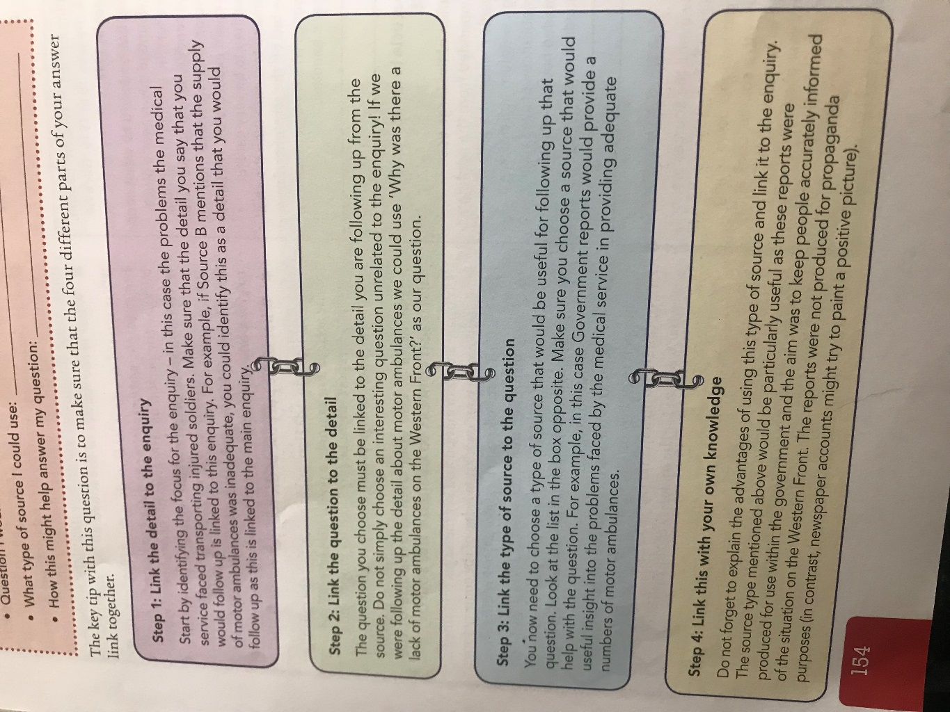
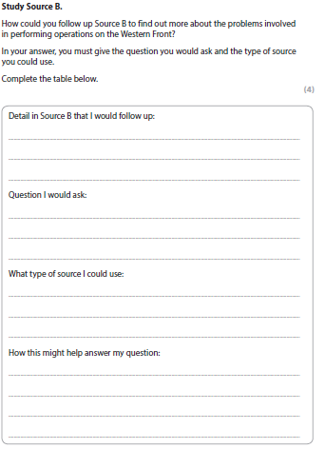

Have to pick a specific quote from the source

What question do you have about this quote?

Ensure it is a specific source e.g. NOT THE INTERNET – soldier’s diaries, nurses diary, national army record, national newspaper articles and reports, government reports on the Western Front, medical articles, hospital records, photographs, personal accounts, local regiment statistics

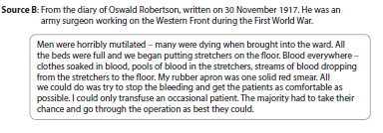
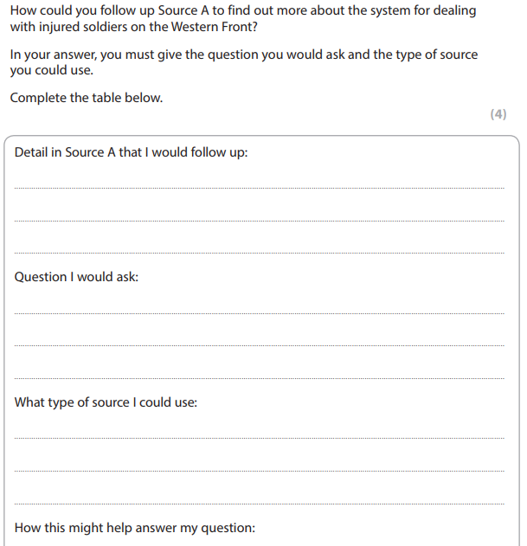

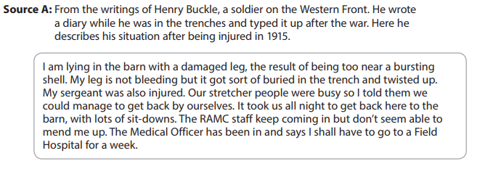

Section B: Medicine in Britain, c1250-present
Question 3: Explaining similarities or differences between two time periods (4 marks – 5 minutes)
This first question tests you on your knowledge and understanding of Medicine from 1250 to present. You have to identify and support your answer with specific details. Examples of questions:
Explain one way in which ideas about the cause of disease and illness were similar in the 14th and 17th centuries
Explain one way in which ideas about the treatment of disease were similar in the 17th century from ideas in the 13th century
Explain one way in which ideas about the treatment of disease were different in the 17th century from ideas in the 13th century
Explain one way in which ideas about preventing the plague were different in the 14th and 17th centuries
Explain one way in which ideas about preventing the plague were similar in the 14th and 17th centuries
Explain one way in which people’s reaction to plague were similar in the 14th and 17th centuries
Explain one way in which ideas about the causes of disease were similar in the 14th and 17th centuries
Explain one way in which understanding of the causes of disease and illness was different in c1750 from the present day
Explain one way in which understanding of the causes of disease and illness was similar in c1750 from the present day
Explain one way in which people’s responses to the 1665 Great Plague in London were similar to the way that people reacted to the Black Death in Britain
Explain one way in which understanding of the causes of illness was different in the late nineteenth and twentieth centuries
Explain one way in which the methods used by doctors to diagnose illness during the medieval period (c1250–1500) were different from the methods used during the modern period (c1900–present).
Model answers:
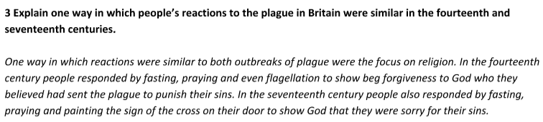

Question 4: Explain why… (12 marks – 15 minutes)
- Two stimulus points which you DO NOT need to use
- No need for an introduction or conclusion
- Do not need to prioritise or link your reasons
- Ensure you have a third reason
- PEEL throughout – point, evidence, explain link

Explain why there was little change in the care provided by hospitals in the period c1250-c1500.
You may use the following information in your answer (ideas in the church; herbal remedies)

Explain why there were changes in the way ideas about the causes of disease and illness were communicated in the period c1500-c1700.
You may use the following in your answer (the printing press; the Royal Society)

Explain why there was continuity in the way disease was treated in the period c1500-c1700.
You may use the following information in your answer (the Great Plague; attitudes in society)

Explain why there was rapid change in surgical treatments in the period c1700-c1900
You may use the following in your answer (chloroform; Joseph Lister)

Explain why there was rapid change in the prevention of smallpox after 1798
You may use the following information in your answer (inoculation; the government)

Explain why there were changes in understanding of the cause of disease during the period 1700-1900
You may use the following in your information in your answer (decline of the Church; individuals)

Explain why there was rapid progress in approaches to preventing illness in Britain during the period c1750-c1900
You may use the following information in your answer (the 1875 Public Health Act; the work of John Snow)

Explain why there was rapid progress in disease prevention after c1900
You may use the following in your answer (government intervention; vaccinations)

Explain why there was so much opposition to Jenner’s vaccination against smallpox
You may use the following information in your answer (Inoculation; the Royal Society)
Explaain why there was rapid change in the understanding of the causes of disease c1700-1900
You may use the following in your answer (Germ Theory; the work of Robert Koch)
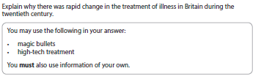
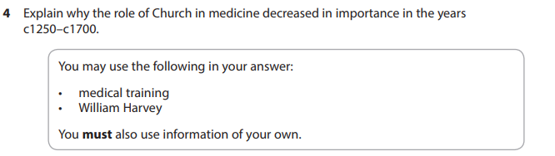
Model answers:
Explain why there was rapid change in the treatment of illness in Britain during the twentieth century.
The first reason for the rapid change in the treatment of illness in Britain during the twentieth century is the development of new technology in order to treat illness more effectively. For example, the work of Marie Curie resulted in the development of x rays to enable the use of radium to diagnose cancer and radiotherapy to treat cancers. This was important because without the technology to treat cancer in this way the disease more often than not led to the death of the patient. Another example of new technologies producing rapid change can be seen in the invention and use of dialysis machines. These have proven vital to treatment of patients suffering kidney failure as they keep the patient alive whilst they await a transplant becoming available. This meant that many patients who would previously die from kidney failure have recovered.
Another reason for the rapid change in the treatment of illness has been the increased focus on improving public health. For example, at the time of the establishment of the NHS in 1948 an estimated eight million people in Britain had never seen a doctor before. The NHS meant all citizens could benefit from free health care such as vaccinations, blood transfusions, hospitals and even home visits. The wide range of services provided by the NHS have dramatically improved life expectancy as illnesses can be diagnosed and treated earlier and previously high risk procedures like childbirth no longer regularly lead to the death of the mother. In addition, the focus on public health has led to increased government action to improve access to treatment such as free medical treatment in schools from 1912.
A further reason for the rapid change in the treatment of illness in Britain has been increased investment of pharmaceutical companies in research and mass production of effective medicine. For example; companies such as Glaxo-Smith- Kline and Boots have invested in research and development of better remedies and used industrial technology to make vast quantities of each remedy in order to make available to the consumer. Competition between the companies has also made it integral that companies ensure people are aware of the products and that the price is affordable for ordinary people. This has resulted in widespread use of painkillers such as aspirin and paracetamol which can effectively combat the effects of illness and aid recovery.
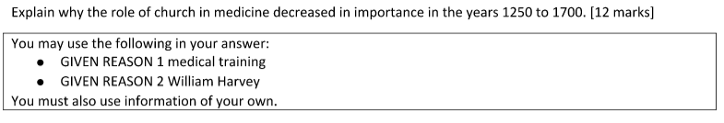
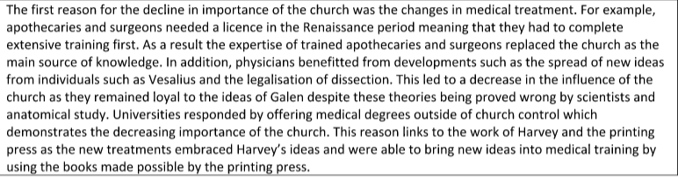
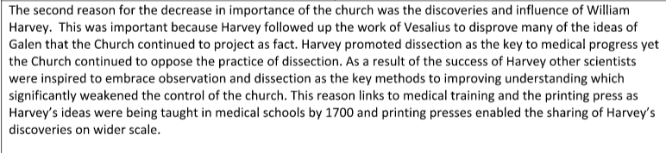
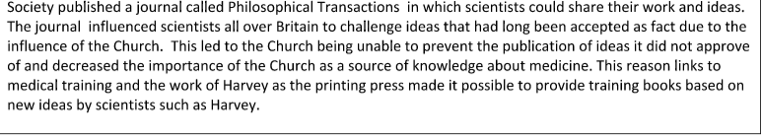

Explain why there was rapid change in surgical treatments in the period 1700-1900. [12 marks]
You may use the following in your answer:
- Chloroform
- Joseph Lister
You must also use information of your own.

One major reason that there was rapid change in surgical treatments between 1700 and 1900 was the discoveries of Joseph Lister. Joseph Lister made a huge impact on surgery with the discovery of antiseptics. This significantly reduced the risk of infection because he discovered Carbolic Acid kills germs which were causing infection during surgery resulting in the deaths of many patients. This resulted in the death rate dropping from 46% of patients to 15% following major surgery. Infection was more understood which made rapid change possible because doctors and surgeons would take necessary steps to reduce the chance of infection such as washing their hands and sterilising equipment. This had an immediate impact and enabled rapid change.
Another individual James Simpson made an important contribution to the rapid change in surgical understanding. Simpson discovered that chloroform could be a reliable and safe anaesthetic compared to ether and laughing gas. By ensuring patients remained unconscious throughout the duration of the operation he was able to prevent the deaths caused by shock. In addition, this was important because it gave surgeons longer to work on the patients and in the long term led to greater understanding of how to use surgery to address complex anatomical problems. As the knowledge of surgeons improved so too did the effectiveness of surgical treatments. Initial reluctance to trust Simpson’s discovery was overcome by Queen Victoria opting to use chloroform in childbirth. This guaranteed widespread acceptance of chloroform and proved a catalyst for rapid change in surgical understanding.
Finally, Louis Pasteur’s germ theory made the improvements to surgery that were pioneered by Lister possible. General health improved in general as more people were aware of the importance of hygiene and less surgical procedures were necessary for avoidable conditions. Acceptance of germ theory by the medical establishment made it possible to prove the effectiveness of Lister’s methods.

Question 5 or 6 (do not answer both) – 16 + 4 SPAG marks: approximately 25 minutes
STATEMENT: ‘..............................................‘ How far do you agree? Explain your answer. [16 marks + SPAG = 20 marks]
You may use the following in your answer:  - GIVEN REASON 1  - GIVEN REASON 2  You must also use information of your own. The given reasons are suggested reasons but you will not be penalised for using others you are more confident on. | Criteria to consider:  - importance of individual: impact - immediate / short term / long term  - extent of change: who was affected / how were they affected  - pace of change: immediate / rapid / gradual / stagnant

1. ULTRA, ULTRA BRIEF INTRODUCTION!
I agree / disagree with the statement that …. The criteria that led to this judgment is …..

2. Support the statement with reasons.  [Evidence to support the statement - make sure you make reference to your criteria and use at least three examples] | Useful phrases  It can be argued that… The statement is accurate because… This was important because… For example… This led to…. As a result of… This is shown by… This evidence suggests/demonstrates/illustrates... | Useful words  irrelevant… negligible… trivial… minor… indirect… major… substantial… fundamental… crucial… decisive… pivotal… accelerated… hindered… exacerbated… indicated… highlighted… reflected…

3. Counter the statement with an alternative suggestion.  [Evidence to counter the statement - make sure you make reference to your criteria and use at least three examples] | Useful phrases  However… on the other hand.... conversely… compared to… Alternatively… It could be argued that... | Useful words  irrelevant… negligible… trivial… minor… indirect… major… substantial… fundamental… crucial… decisive… pivotal… accelerated… hindered… exacerbated… indicated… highlighted… reflected…

4. Counter the statement with another alternative view  [Evidence to counter the statement - make sure you make reference to your criteria and use at least three examples] | Useful phrases  However… on the other hand.... conversely… compared to… In addition... | Useful words  irrelevant… negligible… trivial… minor… indirect… major… substantial… fundamental… crucial… decisive… pivotal… accelerated… hindered… exacerbated… indicated… highlighted… reflected…

5. Reach an overall conclusion | - State judgment  - Acknowledge strength of alternative view  - Repeat your most persuasive piece of evidence and explain how it fits your criteria. | Useful phrases  In conclusion… finally… on balance… in summary… overall… to conclude

“Hospital treatment in England in the period from 1250 to 1500 was very rare.”
How far do you agree? Explain your answer (charity hospitals; care in the home)

“Individuals had the biggest impact on medical training in the 16th and 17th centuries.”
How far do you agree? Explain your answer (Vesalius; the printing press)

“There was rapid change in ideas about the causes of illness and disease in the period c1700-c1900”
How far do you agree? Explain your answer (Spontaneous generation; Louis Pasteur)

“Louis Pasteur’s publication of the Germ Theory was the biggest turning point in medicine in the period c1700-c1900”
How far do you agree? Explain your answer (Edward Jenner; Robert Koch)

“Treatment of diseases and care of the sick completely changed after c1800.”
How far do you agree with this statement? Explain your answer (magic bullets; the NHS)

“Vesalius’s work on anatomy was a major breakthrough in medical knowledge during the period 1500-1700”
How far do you agree with this statement? Explain your answer (Vesalius; printing press)

“Simpson’s use of chloroform as an anaesthetic was a major breakthrough in surgery during the period 1700-1900”
How far do you agree? Explain your answer (chloroform; antiseptics)

“Jenner’s vaccination against smallpox was a major breakthrough in the prevention of disease in Britain during the period c1700-c1900”
How far do you agree? Explain your answer (cowpox; cholera)

“John Snow’s work linking water with the spread of cholera led to major breakthroughs in preventing the spread of disease.”
How far do you agree? Explain your answer (the Broad Street Pump; the Public Health Act, 1875)

“Medical treatments and preventions during the Medieval period were based on religion and superstition.”
How far do you agree? Explain your answer (Bloodletting and purging; praying and fasting)

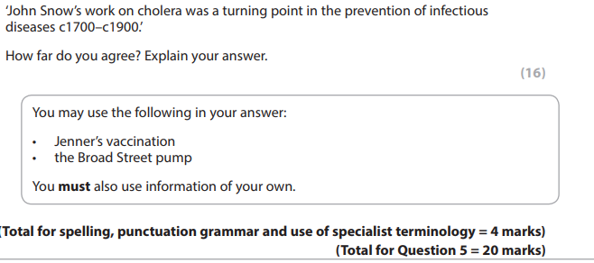

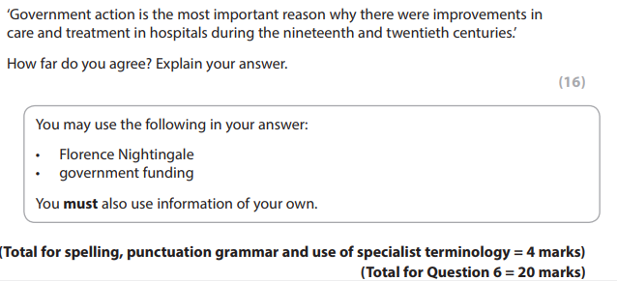

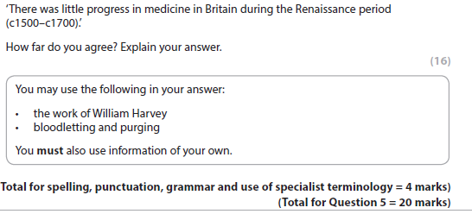

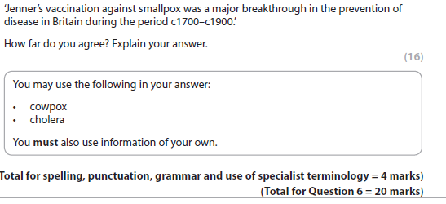
Model answers:
Jenner’s vaccination against smallpox was a major breakthrough in the prevention of disease in Britain during the period c1700-1900.’ How far do you agree? Explain your answer.

I disagree with the statement that Jenner’s vaccination against smallpox was a major breakthrough in the prevention of disease. The criteria that led to this judgment is that the discovery had little short or long term impact on understanding of prevention of disease.
The statement could be argued as accurate because the vaccination against the smallpox was the first time in recorded medical history where a specific disease could be prevented effectively. For example, before Jenner’s discovery the most celebrated development was the practice of inoculation yet this was unreliable and had many problems so cannot be considered a breakthrough. As a result of the development of the vaccination the death rate for smallpox declined dramatically and many lives were saved which would otherwise have been lost to a previously fatal disease.
However, it could also be argued that the statement is inaccurate as it over states the significance of the breakthrough for prevention of disease in Britain. For example, the discovery did not lead to a widespread implementation of vaccination as a method of preventing disease. This was because many people were resistant to the idea of being injected with a disease associated with an animal plus there were several cases where the incorrect application of the vaccination led to the perception that the vaccination was ineffective. As a result of this preventative methods against disease stayed much the same including local authorities promoting the belief that burning tar could counteract the ‘miasma’ which was widely believed to be responsible for the cholera outbreaks of the nineteenth century. This demonstrates that far from a major breakthrough, Jenner’s vaccination had minimal impact on approaches to disease prevention.
A further reason why the statement can be challenged is the lack of transferable knowledge resulting from the breakthrough. For example, although vaccination of smallpox proved successful it was based on a chance discovery relating to a specific disease. Jenner could not explain why his discovery worked meaning it had little impact in furthering understanding of how diseases could be prevented. As a result of this when cholera emerged as a new threat in the nineteenth century, there was nothing that could be applied from Jenner’s discovery to prevent new diseases. It was not until the publication of germ theory by Pasteur in 1861 and subsequent developments in bacteriology by Robert Koch that a true breakthrough was achieved in the fight against disease.
In conclusion, it is clear that the statement overstates the significance of Jenner’s discovery. In isolation it was undoubtedly an important development that saved many lives, however the fact that it did not further medical understanding of disease meant it was of little short or long term consequence for medical capacity to prevent the spread of disease.

‘There was little progress in medicine during the Renaissance period (c1500 - c1700).’ (16+4 SPAG)
Firstly, it can be argued that there was little progress in medicine during the Renaissance period because public health did not improve. In order to judge that progress has been made there would need to be evidence that people in the Renaissance were healthier than their predecessors. The statement is accurate because there was no improvement in average life expectancy when compared to the medieval period which preceded it.
Secondly, ideas about cause of disease were still dominated by inaccurate belief in miasma and the continued acceptance of the four humours as a theory. It is true that as the importance of the church declined this was a period of pivotal change in terms of searching for new ideas about medicine yet these ideas were slow to be accepted and had no direct use in improving treatment or preventing disease. For all the exciting new experimentation, the discoveries of Vesalius and Harvey had little impact in improving understanding of the causes of disease.
Finally, medical care progress was limited as training continued to be based on learning from textbooks rather than practical experience. A good example was dissection; where despite its legalisation it took until after the Renaissance for the practice to become commonplace. As a result of the slow adoption of new ideas bloodletting and purging continued to be a widespread practice throughout the period. The response to the Great Plague of 1665 illustrates the lack of progress in medicine as neither old ideas such as prayer and fasting or new ideas like the theory of transference had any basis in medical fact for dealing with the epidemic.
However, it can be argued that the Renaissance was a period of fundamental change in medicine where major progress was achieved. For example, ideas about causation progressed from an acceptance of religious ideas to a wide rejection of supernatural explanations and the popularity of rational theories such as seeds in the air. The decline in church control over medical research and the embrace of scientific approaches in itself represents significant progress. People were now searching for new explanations for disease rather than believing that disease was caused by God. Thomas Sydenham was a key figure in leading progression in understanding of causation as his promotion of direct observation and examination replaced astrology and urine charts for the purpose of diagnosis.
Furthermore, compared to the medieval period it was far easier to communicate medical discoveries and theories as a result of the invention of the printing press. For example, in 1665 the newly established Royal Society was able to publish a journal Philosophical Transactions in which scientists could share their work and ideas. This meant that doctors and scientists could study, challenge and build on each other’s research dramatically accelerating progress in medicine. A culture was created of scientific exploration with communication between practitioners enabling rapid development of understanding as demonstrated by Harvey’s discovery of blood circulation as a result of developing the research of Vesalius.
In addition, progress was also significant in treatment; apothecaries and surgeons now needed a licence which could only be gained by training and new ideas from scientists like Vesalius and Harvey were transmitted through books and inspired physicians to become more practical and experimental. For example, by 1700 Harvey’s work was being taught in medical schools and his methods of observation and dissection were copied by others. Galen’s ideas were now discredited and far less influential. The response to the Great Plague of 1665 provides evidence of progress in ideas of appropriate treatment and prevention. For example, streets were regularly cleaned, public gatherings were banned and infected households were quarantined for 28 days which had the effect of reducing the level of mass infection that was evident in 1348.
In conclusion, it is inaccurate to characterise the Renaissance as a period of little progress in medicine. Although the outdated beliefs and treatments such as miasma and bloodletting continued this can be countered by the fundamental changes in the culture of scientific exploration and experimentation through the establishment of Royal Society, the seismic impact of the printing press in communicating new discoveries and the integration of scientific discoveries into the training of medical practitioners. In summary, although there was limited evidence of measurable progress at the time, the Renaissance was a period of immense progress in human understanding of medicine.

Glossary of key terms
Amputation | Removal of a limb by surgery
Anaesthetics | A drug or drugs given to produce unconsciousness before and during surgery.
Anatomy | The science of understanding the structure and make-up of the body
Anthrax | An infectious disease mostly affecting animals and occasionally people
Antibiotic | A drug made from bacteria that kill other bacteria and so cure an infection or illness
Antibodies | A substance produced in the body to counter infections
Antiseptics | Chemicals used to destroy bacteria and prevent infection
Apothecary | A pharmacist/chemist
Astrology | The study of planets and how they might influence the lives of people
Bacteria | A tiny living organism, too small to be seen by the naked eye, that causes diseases
Battalion | Between 800-1000 men fighting in WW1
Biochemistry | The study of chemical processes that occur in living things
Bleed/bleeding | The treatment of opening a vein or applying leeches to draw blood from the patient. Also means the loss of blood caused by damage to the blood vessels
Cell | The basic unit of life that makes up the bodies of plants, animals and humans. Billions of cells are contained in the human body
Cesspit | A place for collecting and storing sewage
Chemotherapy | Treatment of a disease, such as cancer, by the use of chemicals
Chloroform | A liquid whose vapour acts as an anaesthetic and produces unconsciousness.
Contagion | The passing of disease from one person to another
Cranium | The skull
Dispensary | A place where medicine is given out
Dissection | The cutting up and examination of the body
DNA | Deoxyribonucleic acid – the molecule that genes are made of
Dysentery | A severe infection causing frequent bowel movements
Epidemic | Widespread outbreak of a disease
Excision | Cutting out
Faeces | Waste material from the stomach and digestive system
Four Humours | The Ancient Greeks believed the body was made up of the Four Humours of liquid – black bile, yellow bile, blood and phlegm
Gangrene (gas) | The infection of dead tissue causing, in the case of gas gangrene, foul-smelling gas
Gene | Part of a cell that determines how our bodies look and work. Passed from parents to children
Germ | A micro-organism that causes disease
Germ Theory | The theory that germs cause disease, often by infection through the air
Gene therapy | Medical treatment using normal genes to replace defective ones
Herbal remedy | A medicine made up from a mixture of plants, often containing beneficial ingredients
Immune system | The body’s defence system again infections and bacteria
Immunotherapy | A method of treating disease by stimulating the body’s immune system to work more effectively
Infection | The formation of disease-causing germs or micro-organisms
Inoculation | Putting a low dose of a disease into the body to help it fight against a more serious attack of the disease
Leeches | Blood-sucking worms used to drain blood from a wound
Ligature | A thread used to tie a blood vessel during an operation
Miasma | Smells from decomposing material were believed to cause disease
Microbe | Another name given for bacteria or micro-organisms
Passive smoking | Involuntary inhaling of smoke
Patent medicines | A medicine usually sold for a profit.
Penicillin | The first antibiotic drug produced from the mould of penicillium to treat infections
Physician | A doctor of medicine who has trained at university
Physiology | The study of how the body works
Plague | A serious infectious disease spread to humans by fleas from rats and mice
Public health | Refers to the well-being of the whole community
Pus | A pale yellow or green fluid found where there is infection in the body
Quarantined | Separated from the rest of the local community because of illness
Radiotherapy | Treatment of a disease, such as cancer, by the use of radium
Remedy | A drug or treatment that cures or controls the symptoms of a disease
Smallpox | A dangerous disease causing fever that was a major cause of death until it was beaten by vaccination
Sterilise | To kill all living micro-organisms from surfaces and surgical instruments
Superstition | An unreasonable belief based on ignorance/fear
Syphilis | An STI that was common from the late 15th century
Tetanus | A disease in which muscles go rigid or into spasm which can lead to death
Transfusion | The transfer of blood from one person to another
Tumour | A swelling caused by cells reproducing at an increased rate or an abnormal growth of cells that may or may not be cancerous
Vaccination | The injection into the body of killed or weakened organisms to give the body resistance against disease
Virus | A tiny micro-organism, smaller than bacteria, responsible for infections like cold and flu
Wise woman | A woman who was believed to be skilled in magic or local customs

