**Chemistry Revision: Calculations**

Mastery Matrix Points

|  |
| --- |
| Link changes in mass to the word equation for a reaction |
| Calculate the relative formula mass of a substance |
| Calculate the atom economy of a reaction |
| Calculate the percentage yield for a reaction |
| Calculate masses from balanced symbol equations |

Key Knowledge

Law of conservation of mass:

When does it look like mass goes down in a reaction, even though really it is conserved?

How to calculate relative formula mass:

Equations:

Atom Economy =

Percentage yield =

Massunknown=

Understanding and Explaining

1. Calculate the mass of magnesium in this experiment.

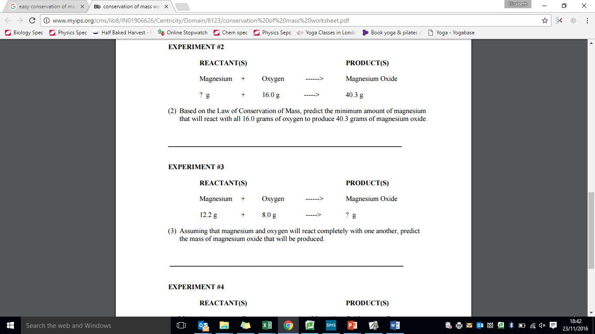

1. Explain why the mass appears to decrease during this reaction.

magnesium + hydrochloric acid 🡪 magnesium chloride + hydrogen

1. Calculate the atom economy for making hydrogen by reacting zinc with hydrochloric acid: Zn + 2HCl → ZnCl2 + H2
2. Calculate the percentage yield of an investigation that expected to produce 495 tonnes of product A, but only produced 400 tonnes.
3. In a reaction, magnesium and hydrochloric acid are reacted together. If 48g of magnesium is used, how much hydrochloric acid is used in grams? Start with a balanced symbol equation.