Chemistry Revision: Elements &
Mastery Matrix Points
Describe and draw a model of the three states of matter
Use the particle model to explain melting, boiling, freezing and condensing
Identify a substance’s state using its melting and boiling point
Classify a substance as an element or compound
Identify the symbol for the first 20 elements
Name common compounds from their formula

Key Knowledge
Definitions:
Element -

Compound –

Melting –
Boiling –
Freezing –
Condensing –

How many elements are in the periodic table? About ____.

Particle model – the atoms are represented as __________________.
Solid | Liquid | Gas

The stronger the forces between particles the __________ the melting and boiling point, so the ______ energy is needed to break the bonds between particles.

Temperature | Solid, liquid or gas?
Lower than its melting point
Between the melting and boiling point
Higher than its boiling point

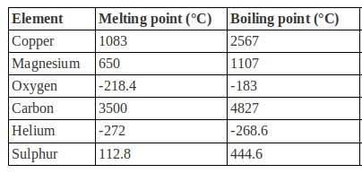
Compounds
Understanding and Explaining
- Describe how the movement and rearrangement of particles changes during
  - Melting
  - Boiling
  - Freezing
  - Condensing
- Use the table to answer these questions.
  - What state would each of the elements be at room temperature (25°C)?

  - Which elements would be a gas at 2000°C?

- The particle model is the simplification that all particles are small, solid spheres. This model is useful for explaining changes of state. Describe the limitations (drawbacks) of this model.

- Are these elements or compounds?
  - Sodium chloride
  - Oxygen gas
  - KI
  - Co
  - CO
- Write the symbols for these elements.
Hydrogen |  | Carbon |  | Sodium |  | Sulfur
Helium |  | Nitrogen |  | Magnesium |  | Chlorine
Lithium |  | Oxygen |  | Aluminium |  | Argon
Beryllium |  | Fluorine |  | Silicon |  | Potassium
Boron |  | Neon |  | Phosphorus |  | Calcium
- Name these compounds.
1. LiO | 6. CuCl₂ | 11. HCl
2. AlCl₃ | 7. H₂O | 12. CaBr
3. MgCl₂ | 8. H₂SO₄ | 13. K₂O
4. FeS | 9. KNO₃ | 14. Al₂O₃
5. NaCl | 10. LiOH | 15. CO₂

