**Physics Revision: Circuits**

Understanding and Explaining

1. **Show how to rearrange the equations V= IR and Q=It.**
2. **Explain how to work out the current in series and parallel circuits, then complete the missing currents.**

In series circuits…

In parallel circuits…

1. **Explain how to work out the potential difference in in series and parallel circuits.**

In series circuits…

In parallel circuits…

1. **Complete the missing numbers on these circuits.**

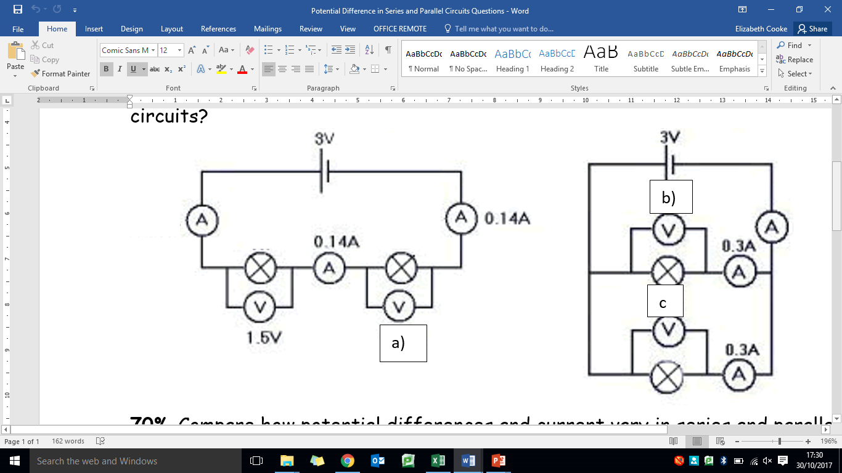 

Key Knowledge

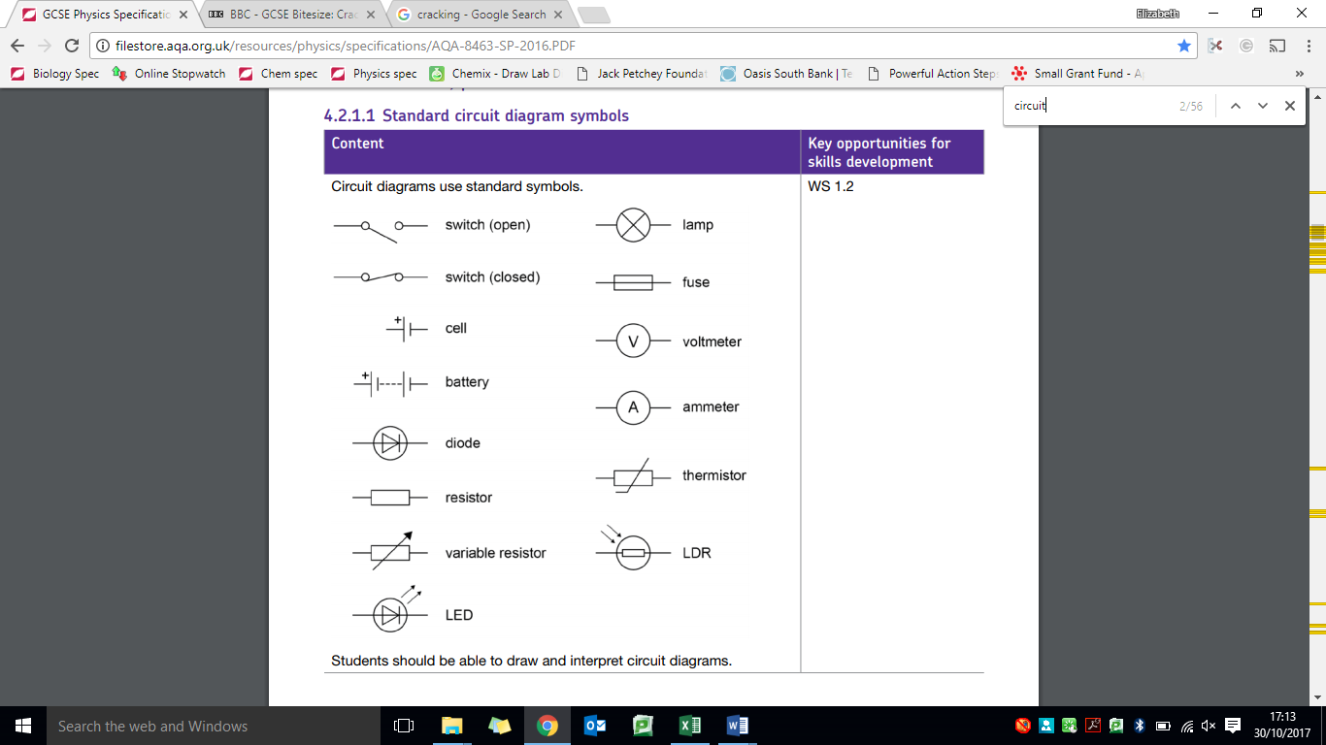Current:

Charge:

Potential Difference:

Equations:

Charge flow =

Potential difference -

Units:

|  |  |  |
| --- | --- | --- |
| **Quantity** | **Symbol** | **Units** |
| Current |  |  |
| Charge |  |  |
| Potential difference |  |  |
| Time |  |  |
| Resistance |  |  |

Mastery Matrix Points

|  |
| --- |
| Identify the key circuit symbols |
| Define current, charge and potential difference |
| Use and rearrange equations for calculating current |
| Predict the current at given points within a series and parallel circuit |
| Predict the potential difference (voltage) at given points within a series and parallel circuit |
| Describe the relationship between current, potential difference and resistance. |
| Use and rearrange equations for calculating current, potential difference and resistance. |
| Recall units for current, potential difference and resistance. |