YEAR 10 DRAMA
BLOOD BROTHERS
Distant Learning Booklet
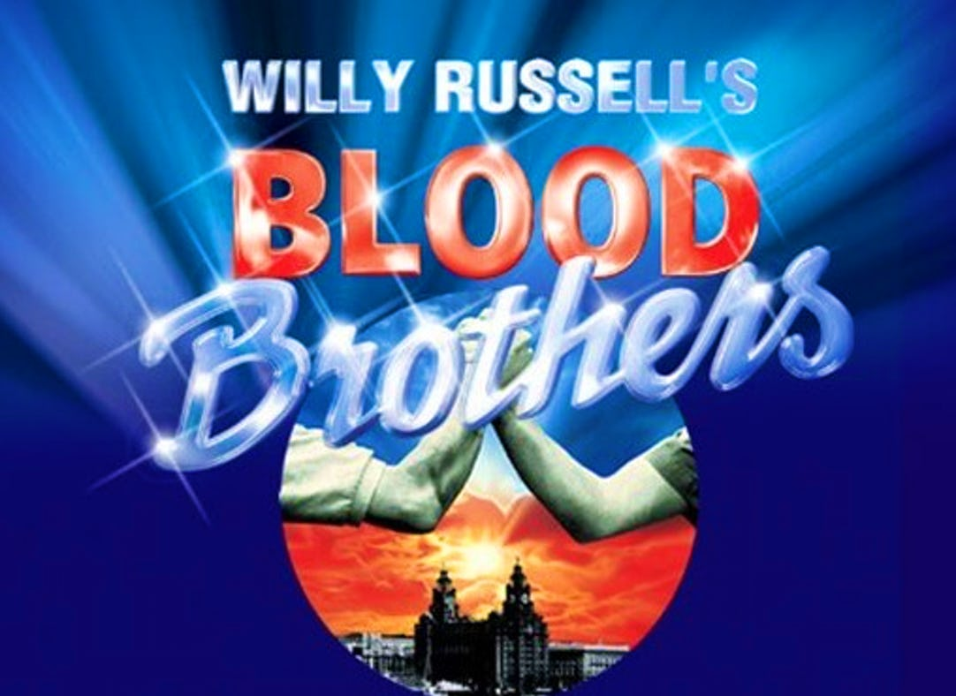

Name:
Teacher:

Activity Log
Use this log to track what work you have completed. Self-assess your understanding of each task- this will help you and your teacher see your progress.
Lesson | Pages | Completed?
Monday 20th April | 4-9
Thursday 23rd April | 10-16
Tuesday 28th April | 17-27
Thursday 30th April

Friday 1st May | 28-39
Monday 4th May

Thursday 7th May

Tuesday 12th May

Lesson | Pages | Completed?
Thursday 14th May

Friday 15TH May

Monday 18th May

Thursday 21st May

NOTE: MORE DATES COULD FOLLOW!

What was Liverpool like between 1960-1980?
Key information
Willy Russell:
- Willy Russell was born in Whiston, near Liverpool in 1947 and grew up in a working class family. His father had been a miner and factory worker.
- Russell was mainly surrounded by women in his early life. Most of the men he knew worked shifts and he believed whist the males were out at work, he absorbed the women’s view of the world by listening to them talking.
- Russell left school at 15 and became a hairdresser. He then began writing folk songs which were performed in local clubs. He also contributed songs and sketches to local radio programmes.
- At 20 years old, he returned to college and became a teacher in the Toxteth area of Liverpool. During this time he began writing drama and completed his first play ‘Keep your eyes down’ in 1971.
- Blood Brothers opened in Liverpool in 1983 at the Liverpool Playhouse and it moved to the West End of London shortly afterwards. It is one of the longest running and most successful West End musicals ever. It has been to Broadway and toured the world.

Time Period (Est 1960’s-1980’s):

- Russell has not specified the time period but in Act One the opening references are made to Marilyn Monroe which has led many directors to assume the opening starts in the late 1950’s, early 1960’s. References to the move from inner city council slums to new houses (Skelmersdale Lane) notably happened in the 1960s also.

- The timeline then takes us through times of economic downturn, job cuts and depression which we can assume links to the late 1970s and 1980’s (Margaret Thatcher’s Era) we can see this in Act Two when Mickey loses his job.

Setting:

- The play set in Liverpool. At the time the city was predominately working class which meant many families were struggling with unemployment and poverty.

Liverpool:
- At the turn of the twentieth century (1900) Liverpool was one of the world’s richest cities.
- Trade with the British Empire flowed through its port and brought with it great economic growth.
- However, as the Empire declined so did the fortunes of the city and by the second half of the century (the setting of Blood Brothers), Liverpool was deep in economic recession. The once bustling docks had fallen derelict and unemployment swept through the city plunging thousands of households into poverty. Crime increased, housing conditions worsened and drug use became widespread.
- Musicals have been used to present social themes and messages to audiences. Russell focuses on highlighting the issues of social class, poverty and unemployment in his musical.

Poverty:
- At the beginning of the play we learn that the Johnstone family are very poor. In the opening scenes Mrs Johnstone reveals that she is an unemployed single mother and we see her struggling to pay her bills (I start a job next week. I’ll have money comin’ in an’ I’ll be able to pay y’) and provide for her family (‘Ey Mother, I’m starvin’ an’ there’s nothin’ in’). Her children are on ‘free dinners’ and lack discipline.
- At the beginning of the play Mrs Johnstone does find a cleaning job but her wage is low and barely enough to live on. For the majority of the first act the Johnstones live in what would be a cramped ‘back to back’ terraced house in Liverpool’s inner city slums.

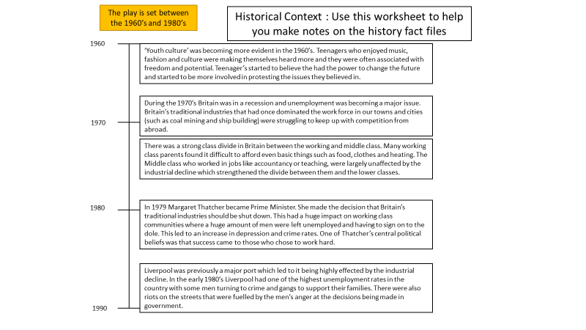
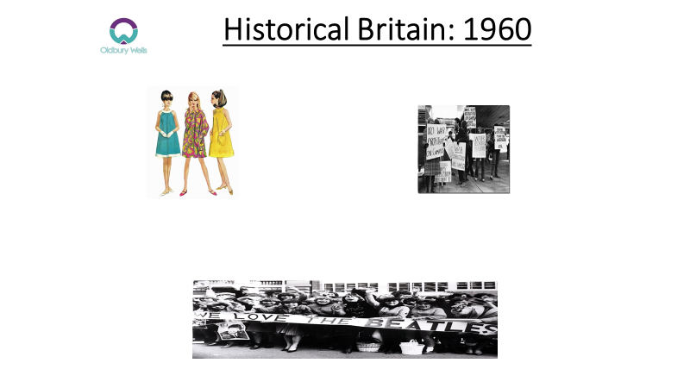
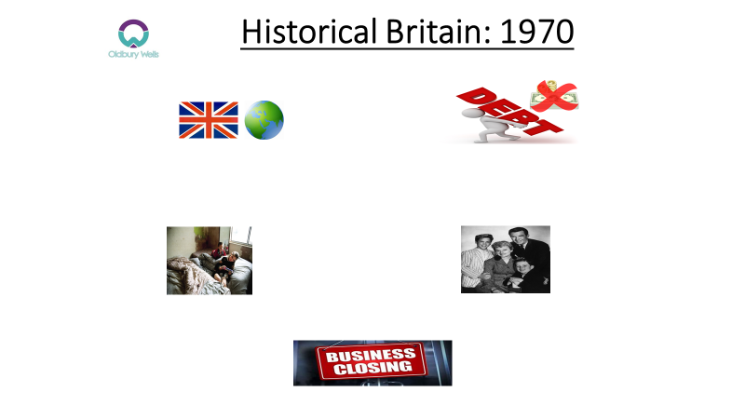
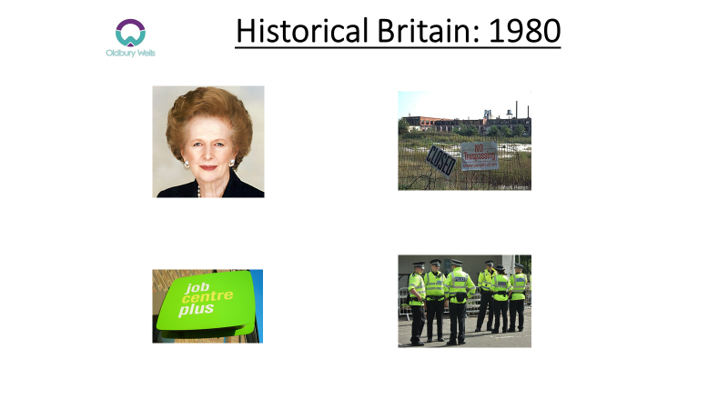

What happens in Blood Brothers?
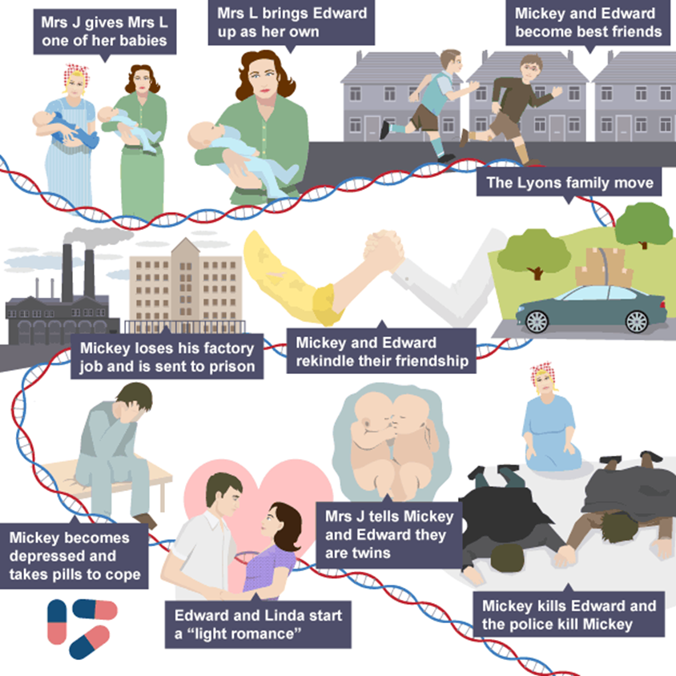

Act 1:
- Mrs Johnstone, a struggling single mother of seven, finds out that she is pregnant with twins. Her employer, Mrs Lyons persuades Mrs Johnstone to give her one of the babies.
- Mrs Lyons takes Edward and brings him up as her own, convincing her husband this is true. Mrs Johnstone goes back to work but fusses over Edward, leading to Mrs Lyons firing her.
- Aged seven, Mickey and Edward meet and become best friends, along with Mickey’s neighbour Linda. The three get into trouble with the police when they begin to throw stones at windows.
- Scared of Edward becoming close to his biological family, Mrs Lyons convinces her husband to move the family to the countryside. Soon afterwards, the Johnstone family (and Linda’s family) are rehoused by the council.
Act 2:
- As teenagers, Mickey and Edward meet again and they rekindle their friendship. Linda and the boys remain close throughout their teenage years before Edward goes to university.
- After marrying a pregnant Linda, Mickey loses his factory job. Unemployed, Mickey is involved in a crime with one of his brothers, Sammy, and both are sent to prison.
- Mickey becomes depressed and takes pills to help him cope, which he continues to take after being released.
- After Mickey comes out of prison and starts a new job, Edward and Linda start a light romance. Mickey finds out and is furious so he finds Sammy’s gun and goes to find Edward at his workplace, the town hall.
- Mrs Johnstone follows Mickey and tells him in front of Edward that they are twins. The police also arrive.
- Mickey waves the gun around and it accidentally goes off, killing Edward. The police shoot Mickey. The twins both lie dead.

Transfer information from this page to help you complete your story board

Story Board: Act 1

What is happening in this scene?

What is happening in this scene?

Story Board: Act 1

What is happening in this scene?

What is happening in this scene?

Story Board: Act 2

What is happening in this scene?

What is happening in this scene?

Story Board: Act 2

What is happening in this scene?

What is happening in this scene?

Story Board: Act 2

What is happening in this scene?

What is happening in this scene?

Who are the main characters and how would I describe them?

The Johnstone Family

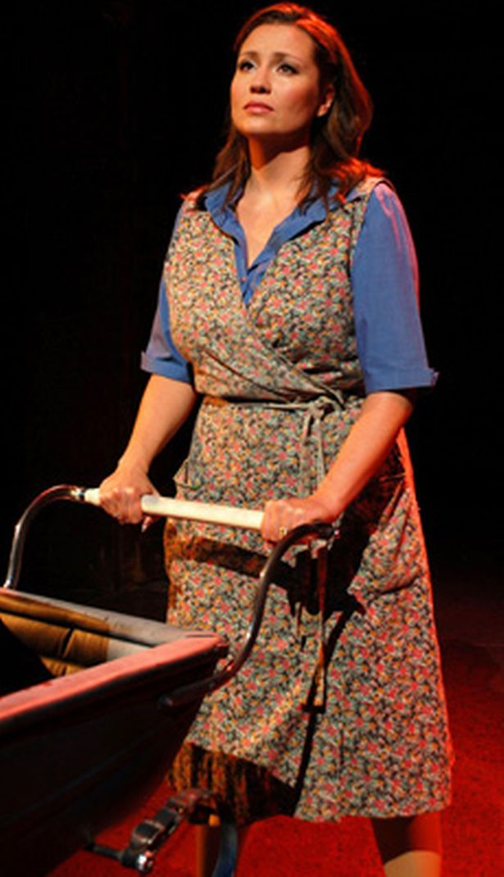
MRS JOHNSTONE
Mickey, Eddie and Sammy’s Mom
Gives Eddie away to Mrs Lyons

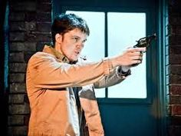
Sammy
Mickey’s older brother
Rebellious character who commits crime

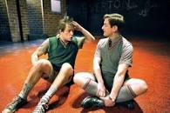
Mickey

Eddie’s twin
Marries Linda
Loses job, turns to crime and struggles with depression
Believes Eddie and Linda are having an affair so tries to shoot Eddie

The Lyons Family
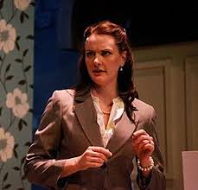
MRS LYONS
Eddie’s Mom
Middle Class- doesn’t work
Very superstitious

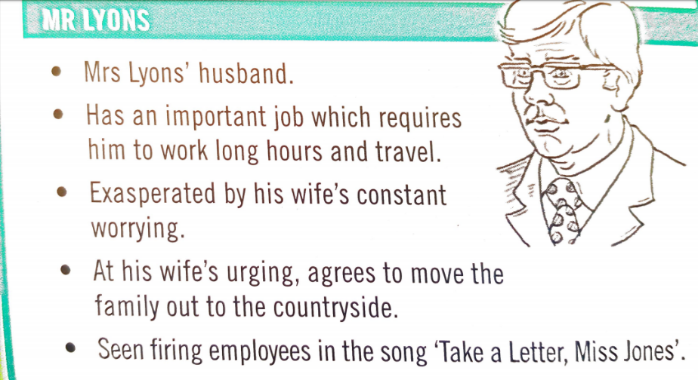
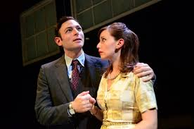
MR LYONS
Eddie’s Dad
Often working away from home
A wealthy businessman

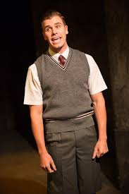
EDDIE
Mickey’s twin
Mrs J gave him away to Mrs L
Confesses that he loves Linda and they start a ‘light romance in Act 2’
Shot by Mickey

Other Characters
LINDA
Working class
Love interest for both Mickey and Eddie

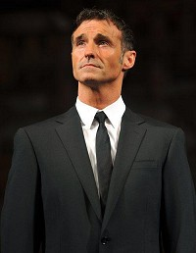
NARRATOR

Look at these descriptive words and decide which character they best describe. Mrs J, Sammy, Mickey, Mrs L, Mr L, Linda or Narrator- some words may link to more than one character.
Describing Word | Character
Flirtatious
Protective
Middle Class
Mysterious
Fearful
Working Class
Bully
Professional
Protective
Criminal
Youthful
Cheeky
Posh
Superstitious
Eerie
Good natured
Educated
Obsessed
Loving
Loyal
Boisterous
Naive
Confident

Confusing

Desperate
Attractive
Powerful
Wealthy
Awkward
Streetwise
Depressed
Cunning

Character Profiles: Mrs Johnstone
Draw a picture of this character in costume

Facts about this character:
Name:
Age:
Occupation:
Family:
Relationships:
Lifestyle:
8 ways to describe this character

My Interpretation of Mrs Johnston is that she is a ____________________ working class woman who is always scrambling to get by. Mrs Johnstone is __________ hearted and has a strong sense of ______________ values. She is a _______ mother who loves her children dearly and will do anything to protect them. As the play goes forward, Mrs Johnstone becomes tortured by __________ and regret by giving up one of her twins. Despite this, she remains kind and loving through her grief. She is the moral centre of the play and could be described as the ______________.

Protagonist, guilt, family, loving, hardworking, family, single

Character Profiles: Mrs Lyons
Draw a picture of this character in costume

Facts about this character:
Name:
Age:
Occupation:
Family:
Relationships:
Lifestyle:
8 ways to describe this character

My Interpretation of Mrs Lyons is that she is a ____, upper-class, ________ woman, the opposite of Mrs. Johnstone. Like Mrs. Johnstone, Mrs. Lyons ________ Mrs Johnstone into giving away one of her children. For Mrs Lyons, this guilt turns into _______ and paranoia. She makes up a superstition to keep Mrs. Johnstone away from Edward and tells him that the _________ will get him. As the play continues, she is so convinced that she will lose her son that she tries to kill _________. Eventually, Mrs. Lyons’ hatred and madness become so pronounced that she reveals Linda and Edward’s ______ to Mickey, thus contributing to the murder of her adopted son.

Wealthy, snobbish, manipulates, suspicion, bogey man, Mrs Johnstone, affair

Character Profiles: Sammy
Draw a picture of this character in costume

Facts about this character:
Name:
Age:
Occupation:
Family:
Relationships:
Lifestyle:

8 ways to describe this character

My Interpretation of Sammy is that he is the ‘bad apple’ of the ______family, Sammy begins the play as an object of envy for his younger brother, ______. Dropped on his head by a young Donna Marie when he was a baby, Sammy quickly becomes a juvenile nuisance, even trying to rob a bus as a teenager, producing a _________ to the driver. Eventually, the adult Sammy turns to a life of________ and persuades the ______________Mickey to help him. This attempted robbery, however, ends with a_______, and Sammy presumably winds up in jail, as does Mickey.

Johnstone, Mickey, crime, knife, murder, unemployed
Character Profiles: Linda
Draw a picture of this character in costume

Facts about this character:
Name:
Age:
Occupation:
Family:
Relationships:
Lifestyle:
8 ways to describe this character

My interpretation of Linda is that her personality changes as we develop throughout the play. To begin with, Linda is a
tomboyish young girl, but quickly morphs into an object of ____________ for both twin brothers. At the beginning of her adolescence, she only has eyes for ___________, even telling him she loves him long before their first kiss. After years of poverty (and Mickey’s imprisonment), however, she turns to Edward for ___________and support, and the two begin an affair (_______ romance). Despite this unfaithful act, Linda is a sympathetic character, one who loves both twins, and is driven to betray her husband by desperate and dismal circumstances.

Comfort, light, Mickey, desire

How do the costumes reflect the play’s context?
REMEMBER: 4 mark question (Blood Brothers question 1) will ALWAYS be a design question (costume, set, lighting or sound)
Condition

Make up
Hairstyle
Fit
Footwear
Accessories
Footwear
Colour
Costume Design
You might consider
Fabric
Cut

Colour
Colour is a very important aspect of a costume. It can convey a symbolic idea or reveal something about the character wearing the costume.
What ideas do these colours convey about a character? Write at least 3 ideas for each colour

RED: Danger, Passion, Anger,

ORANGE:

WHITE:

BLACK:

GREEN:

BLUE:

Condition
The condition of the costume can convey information about a character's circumstances.
What do these costume conditions suggest about the character? Try not to repeat your character ideas

Condition | Suggestion about character
Worn out, ripped, frayed

New, sharp, smart

Neat, ironed out,

Wrinkled, creased, pulled

Clean, fresh,

Stained, dirty, grubby

Cut
Refers to the shape of the fabric
Link the item of costume to its potential cut.

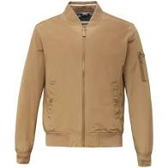
Bootcut
Flared
Straight Leg
Ripped

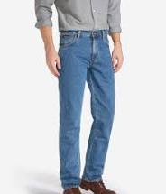
A Line
Mini
Pencil
Flared

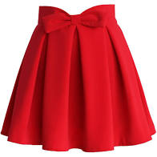
Shirt
Wrap
Tunic
House

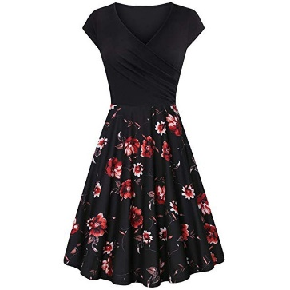
Tailored
Buttoned
Hooded
Bomber

Fabric
The most appropriate fabrics to suit the character, setting and style of the production should be considered.
Which of these fabrics are cheap and which are expensive?
Cotton: Used for a range of clothing items
Cheap Expensive

Denim: Hardwearing, rugged fabric
Cheap Expensive

Velvet: Smooth material
Cheap Expensive

Chiffon: Soft, thin material
Cheap Expensive

Satin: The most elegant fabric
Cheap Expensive

Linen: Light and comfortable fabric
Cheap Expensive

Nylon: Used for a range of clothing items
Cheap Expensive

Tweed: Rough and heavy fabric- traditionally used in men’s clothing
Cheap Expensive

Silk: Soft and luxurious
Cheap Expensive

Fit
The fit of a costume refers to how the clothing fits the performer, It can reveal a character’s personality or the context of the play.
List as many ‘fit’ types as you can
Baggy

Costume: Fit

Tight

Mrs Johnston and Mrs Lyons
Look at the list below of ideas for costume, makeup and hairstyles. Given your understanding of the characters and their roles, label which ones are best for Mrs Johnstone and which for Mrs Lyons.
Hair curled and styled, set with hairspray
Low-heeled, scuffed work shoes
A loose jumper with rolled up sleeves
A polyester tabard style apron
High-heeled patent leather shoes
Red lipstick
A string of pearls
Leather gloves
Yellow washing up gloves
A feather duster
Hair loosely tied back and up styled
A knee-length tweed skirt
Feather duster

Mickey, Edward and Linda aged 7
The costumes for Mickey, Edward and Linda at age 7 should reflect their backgrounds. Look at these notes about costumes for the children at this age and sketch the costume, which is being described, Use colour and detail to emphasise the main ideas.

Mickey
- Baggy hand-me-down shorts, patched and held up with a belt
- An over-sized striped jumper with holes in it
- Rumpled, loose socks and heavy black shoes with white laces
- Mud on knees
- Hair a little too long and sticking up
Add 2 of your own design ideas
1.
2.
What does the costume design suggest about Mickey’s background? Write a paragraph of your ideas

Edward
- Neat grey shorts with a crease ironed into them
- Short-sleeved white shirt, well-pressed and very clean
- A grey sleeveless pullover with a thin orange stripe at the bottom
- Grey socks, neatly pulled up to mid-calf
- Short hair, smoothly parted to the side
Add 2 of your own design ideas
1.
2.

What does the costume design suggest about Edward’s background? Write a paragraph of your ideas

Linda
- A short dress, which is ripped and stained
- Ankle socks and T strap shoes
- Hair up in bunches
- A smudge of dirt on her cheek
Add 2 of your own design ideas
1.
2.

What does the costume design suggest about Linda’s background? Write a paragraph of your ideas

Mickey, Edward and Linda aged 14
Task: Complete designs and annotations for Mickey. Edward and Linda aged 14. Refer to ideas about costume design from all worksheets.
The points below will help you focus your ideas. Nothing is wrong, if you can justify why.

Consider the following
- The characters are 14
- They are interested in being attractive
- At school, they might have to wear a uniform
- For their leisure outfits, they might be influenced by celebrities at the time (1960-1970)
- They might be influenced by magazines and other fashion guides at the time
- They might have limited money to spend on clothing

Use a separate piece of paper for your designs

