 | Oldbury Wells School  Bridgnorth  Shropshire  WV16 5JD  Telephone Number  01746 765454 | 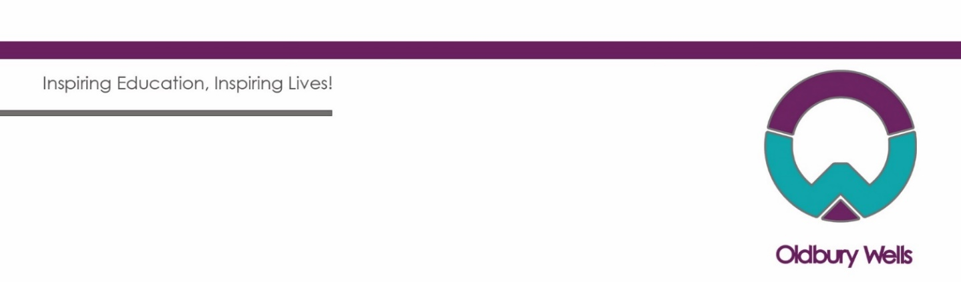

Clerical Assistant (General Administrator)
Contract: Casual, Term Time Only (43.60 weeks)
Salary: Grade 3, SCP 4 (£11.98 per hour)
Weekly Hours: Full time and Part time hours considered. Full time is 37 hours per week
(8am – 4pm Monday – Thursday, 8am – 3.30pm Friday including 30min unpaid lunchbreak)

Job Advert

We are looking to recruit an enthusiastic, reliable and dedicated Administrator to join our school administration team. Under the direction/instruction of senior staff, the purpose of this role is to provide reception administration and general clerical and administrative support to the school.

Experience of working within a previous school administrative role would be an advantage but is not essential. We are looking for an excellent communicator who is organised and able to work on their own initiative as well as within a team.

If you want to be part of a school that is making a difference to individuals, then we welcome your application. If you are a team player with a keen interest for working in an administrative role within a school setting, we would like to hear from you.

The school is committed to safeguarding and promoting the welfare of children and young people and expects all staff and volunteers to share this commitment.

How to apply
Full details of the role and application process are available from the school’s website: www.oldburywells.com/our-school/vacancies.
If you feel you have the qualities to complement our existing team, then we would love to hear from you. Please note CVs will not be accepted. To apply, please download and complete the application form which should be returned to Mrs Kate Dwane, Office Manager, at the school or by email to kate.dwane@oldburywells.com by the closing date below.
The appointment is subject to satisfactory pre-employment clearances including references, medical clearance, and an enhanced DBS Disclosure under the “Rehabilitation of Offenders Act 1974”. Further details regarding this check are available by visiting www.dbs.gov.uk.This school is committed to safeguarding and promoting the welfare of children and young people/vulnerable adults and expects all staff and volunteers to share this commitment.

Application closing date is: 9:00am on Friday 30th August 2024.
Interview date: Week commencing Monday, 2nd September 2024.

